Avanti Suresh
Global Health Experience – Graz, Austria

About Graz, Austria
Graz is the second-largest city in Austria, 200 kilometers away from the capital, Vienna, and has six universities. It has a population of about 300,00 people, and is home to two UNESCO World Heritage sites: the historic old town in the city center and the castle of Eggenberg. Additionally, in 2003, it was named the European Capital of Culture, and in March 2011, it was designated UNESCO City of Design.

Personal Goals for the Trip
My interest in exploring medicine in Austria was piqued during a family trip to Vienna, Austria in 2014. Upon touring different areas, I learned of the long-standing history of medicine in Austria, and the strong reputation of the Austrian medical universities. During my M1 year when I was brainstorming summer plans, I was pleased to learned that Robert Wood Johnson Medical School had ties with a medical school in Austria, the Medical University of Graz. I was very excited about taking part in this opportunity, as I have always been curious about the differences in healthcare abroad, especially in Europe, given that the healthcare system is so different than ours in the United States. Additionally, I wanted to explore my interests in the field of Pediatric Surgery, and was excited to find that this program would afford me the chance to gain clinical experience in this field. Also, I was interested in looking at how the attitudes towards medicine differed in Austria, both from the patients’ and physicians’ perspectives. I also viewed this program as an opportunity to explore the city of Graz, which is somewhere I had never visited before, but was interested in exploring.

About the Observership Program
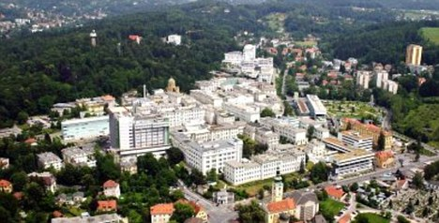
The Observership program at the Medical University of Graz aims to give individuals in the field of healthcare an opportunity to gain insight into the Austrian medical system as well as to provide a multifaceted clinical experience. The program affords medical students, doctors, and other healthcare professionals the opportunity to shadow doctors in a number of different departments, allowing for them to experience new techniques and treatments, have discussions with responsible physicians and monitor surgeries and other invasive interventions. The Medical University of Graz, ranked among the top 200 (151-200) World Universities, is a university hospital with 1,500 beds, around 410,000 outpatients, and around 82,000 inpatients each year.

The Medical University of Graz
Program Overview
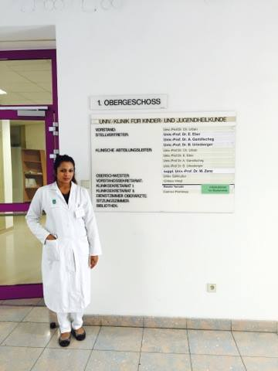
I was enrolled in the Clinical Observership Program at the Medical University for a month, and was able to select the department of my choice, Pediatric Surgery. Upon arriving at the hospital on my first day, I was given a rotation schedule for the month, which had me spending each week at a different station or ward. I spent three weeks rotating through different floors and wards, and spent one week in the “Ambulanz” station, which is considered the emergency care center in the pediatric surgical department. Through the whole month, I was able to spend half my day observing the clinical patient visits, and spent the other half observing procedures in the operating rooms. Each day, I was provided with the surgical schedule, and I was able to choose to shadow the operation of my choice. It was a great experience being able to see so many different procedures, and it helped me become more comfortable in the operating room. I gained a greater appreciation for and insight info the surgical specialty.
In the Pediatric Surgery Department

Reflections and Conclusions
While Austrians in the university hospital technically spoke English, the primary language of communication there was Austrian German. This posed an obstacle for me, as I had previously never studied any form of German before. Fortunately, I was able to make the most of the experience and found a few residents that were fluent in English and helped translate the clinical encounters and schedules for me, and met doctors who were willing to help out and explain.

Aside from the language differences, I noticed the medical system was inherently different in so many ways. The patients had very different attitudes towards physicians and the medical field in general. They respect physicians a lot more, and really look to them for guidance and have a lot more trust in the medical system. This differs from America slightly, as America is a more litigious system, so patients are slightly more skeptical and question the decisions made by their physicians more. Additionally, Austria has both public and private health care, so all Austrian citizens are able to have access to physicians whenever they need. Austria has a good system with regards to this, as everyone is able to be healthier because the government covers all of the physician visits, thus not limiting access to health based on socioeconomic measures.
Overall, this was such a great opportunity that provided me with amazing experiences and insights. I was able to navigate a foreign country where I did not speak the language on my own, and was constantly immersed in learning about a new culture and medical system, along with meeting international people along the way. I was able to open my mind up so much and learn from the other medical students and physicians around me. I was very excited to see certain procedures where physicians from other countries would come shadow the operations in order to learn new techniques. I met a pediatric surgeon from Armenia, and was able to learn a bit from him about what medicine was like there. After this trip I definitely would consider exploring the European medical system further and consider doing some elective rotations abroad.

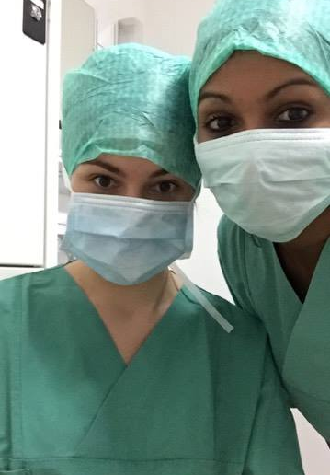

Getting ready to observe an operation with another medical student (from Turkey)

References

http://en.unesco.org/creative-cities/graz

https://smediacacheak0.pinimg.com/564x/3d/4d/61/3d4d61370c2ab25f8e7c2c6ad064c347.jpg
http://postgraduate-school.medunigraz.at/observership-program/

