Justin Marson
Global Health Reflection – Taiwan

Patient-centered medicine. Three simple words, but when applied divide the healthcare landscape that we have only begun to preach in the United States from the practices of the physicians in Taiwan.

Our introduction to Taiwan’s take on treatment and care took us to the rural mid-west part of the island, to a region called Jiayi. The locals joke that the only inhabitants of Jiayi are the elderly, children, and dogs. This punchline gets a morbid twist when one considers that the hunt for work has stripped Jiayi of much of the working-age adults, most flocking to larger cities—primarily Taipei in the north. As such, over 65% of Jiayi’s population is over 65 years of age. Although this predicament would seem to have left much of Jiayi’s vulnerable population to fend for themselves, it was not uncommon to see elderly not only exercising and socializing, but even taking care of their seniors.

In cooperation with National Taiwan University Medical School（NTU MS, 台大醫學院）and a local nonprofit, XinGang Foundation of Culture and Education, we had the rare opportunity to see the multifaceted approaches that the foundation had taken to better their community. At the heart of their methods lies the theory of upstream medicine: proactively fending off disease before it presents as a problem.

One of the foremost issues facing the elder population of Jiayi is food security. Many of the elders are alone and homebound during a large portion of the day. If food is not prepared for them, chances are they will not eat. Fortunately, filial piety plays a large part in Chinese culture; a local buffet and volunteers working with the XinGang foundation brings lunch boxes to these Ah-Mas and Ah-Gongs (taiwanese for grandma and grandpa). More importantly, these drop-offs are an opportunity to interact with the ah-ma’s and ah-gong’s, and, as medical students, a chance to take a history and see if medical attention is required.

With the advent of the high-speed rail, a bullet train that connects the entire western coast of Taiwan, from the northern tip of Taipei to the southern end of Kaohsiung, many of the old train stations went into disuse, including the one that traversed Jiayi. Jiayi went through a tumultuous period where citizens cared more about convenience than their community. As such they turned the abandoned train station into a local landfill; the once hustling stop was now no more than a congested pile of refuse, all in their backyard. The XinGang foundation took it upon themselves to clean the area and turn it into a green space—a public park for the community. In the park now sits a vestige of the old line—an antique rail car sitting upon two strips of parallel metal lines—along side the works of local artists. The day we visited, even though the hot summer sun beamed down on us, there were families and children enjoying the community park, a park for the people and maintained by the people with a communal sense of pride for having made such strides—from junk yard to treasured park.

And on the third day, we truly saw fusion of community and medicine. We had the rare opportunity to visit a mobile clinic that traversed the Taiwanese country side. Because hospitals and care facilities are not always easy to reach, especially for someone homebound (if not bedridden), these mobile clinics (coach buses hollowed out and outfitted with mammograms, ultrasound, and x-ray, capable of taking blood and basic diagnostic testing) brought the hospital to the countryside. As the Ah-Mas and Ah-Gongs waited to meet with physicians of all specialties (from opthamology and cardiology to family and traditional Chinese medicine), they were entertained by a local comedian and public health advocate and even received a small talk from the NTU medical students about precautions they should take in the wake of the MERS outbreak and to safeguard against Dengue fever.

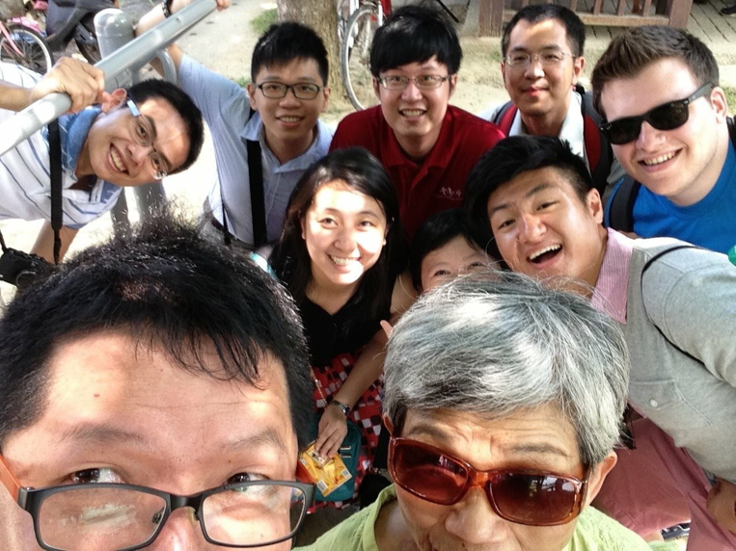
And yet, nothing epitomizes this sense of community more than this one picture.
During the screening, an Ah-Ma approached us as the comedian/public health advocate led a group discussion on community health. In her hands she held her cell phone; suprisingly enough, she asked to take a “selfie” with us. As it turns out, the meaning of a selfie differs in a Taiwan; whereas in America a selfie embodies narcissism, in Taiwan, because the group of people must be so close to take the photo, it personifies the closeness—a sense of community.

Upon our return to the north, we visited JinShan (金山, literally translated Gold Mountain) on the outskirts of Taipei where a branch of the NTU hospital performs home visits for its population. Similar to, but not as extreme as, JiaYi, JinShan also has an aging population with few of the younger generation around (during the day or at all) to care for them. The program, called the golden cloud, had doctors and nurses visit patients’ homes twice a month to perform routine care and help train live-in aids (often from countries like Thailand or the Philippines) in caring for a patients’ specific needs.

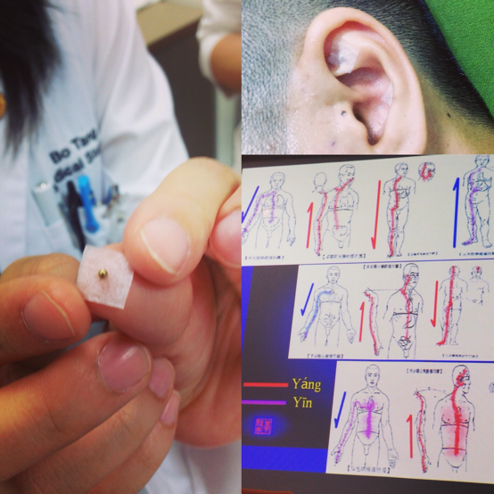
The second half of our program took us to another hospital, the Veteran’s General Hospital (VGH, 榮總醫院) where we learned about traditional Chinese medicine (TCM). Patients walked into a clinic area and, after a brief consultation period with the attending physician, during which a brief history was elicited and abbreviated physical performed, patients proceeded to a common waiting area where they received their acupuncture treatment (if deemed necessary by the attending). Although much of modern meta-analyses and RCTs studying the efficacy of acupuncture have shown that much of the effects can be attributed to placebo, for many of the patients, a placebo seemed to do the trick. Notably, as the patients waited patiently, they chatted with each other, bonding over life and loss, and a sense of community and empathy forming, all while needles pierced their muscles. I couldn’t help but think, that, like in JiaYi, just having this form of contact, in some way, improved the health and well-being of these patients, many of whom suffered from myalgias that, as of this moment, are incurably by western medicine. As a good friend of mine always said, “[Acupuncture] might be a placebo, but if it helps the patient, what’s the problem?” In this case, perhaps compassion from a physician, empathy from the community, and punctures from steel needles are exactly what the doctor ordered.

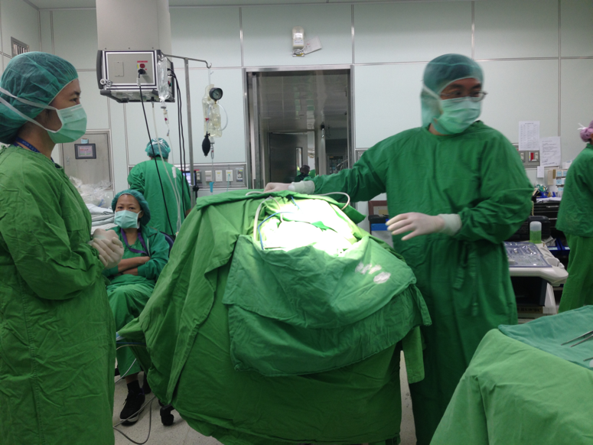
In the traditional medicine clinic, we rounded with physicians and learned not only about the practice of TCM, but also about the practice of social medicine (at least in Taiwan). By paying a small annual fee, any Taiwanese citizen receives almost unlimited treatment from hospitals and free clinics. In a morning, it was not uncommon for a physician to see upwards of 200 patients. However, doctors only took home about $3 USD per patient seen. In this way Taiwanese physicians tried to make up for what they lost in payment with volume of patients. This discrepancy in payment was even more evident among surgeons. During our time in Taiwan, we also had the rare opportunity to scrub into the neurosurgery OR of NTU. On one occasion, we witnessed an amazing case: a woman presented with bilateral internal carotid aneurysm proximal to the circle of willis. The left aneurysm burst and was quickly blocked using metal coils; the right aneurysm was then circumvented using a graph of the great saphenous vein, rerouting blood from the external carotid in the neck to a point distal to the aneurysm on the internal carotid before also blocking the aneurysm with a coil as well. This entire procedure took over 7 hours. The patient didn’t have to pay a dime; yet the lead neurosurgeon only took home $2000 USD.

Although Taiwanese physicians complain about their system: the poor pay and the overload of patients (who proceed to doctor shop because they can), among other problems, it is interesting that they do not see how green the grass is on their side of the fence. They managed to achieve in an incredibly rural area a type of upstream medicine that America is only on the verge of teaching, on the edge of exploring. Perhaps America should take a few notes about the Taiwanese success. To truly be patient-centered in approach, medicine must be tailored to the population. More importantly, people must become responsible for not only their health, but also the health of their environment, and, above all, the health of their community.

