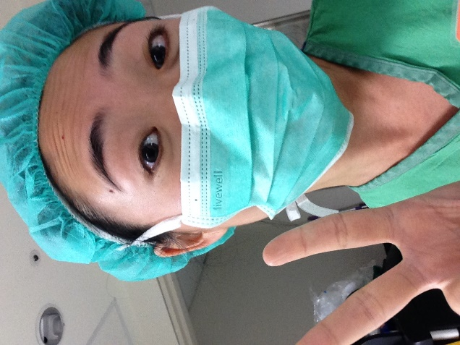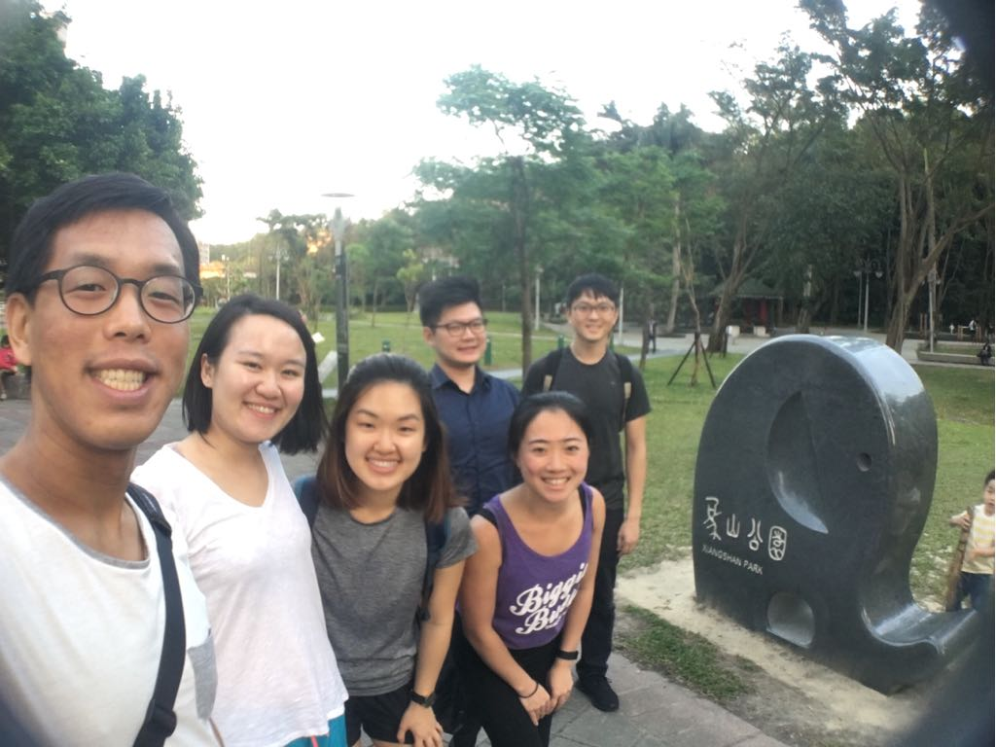

NTU Hospital International Rotation
Deborah Chen
March 2018

Having had previous global health experiences in India and Tanzania, I knew that my international rotation in Taiwan would be another great one – but I had no idea what a difference it would make to rotate internationally as an M4! As I did in previous exchanges, I was able to appreciate differences in health care models and physician attitudes, but the breadth and depth of medical knowledge I’ve picked up over the years allowed me to delve even deeper into these differences, and to recognize the fine detail changes in medications, protocols, and procedures.

Clinically, a peer and I were able to see various settings: inpatient medicine and hospice wards, home visits with a physician-nurse team, the ER, obstetrics and gynecology (including the operating room and labor rooms), travel medicine clinic, smoking cessation clinic, and obesity clinic. We saw both a university hospital and community hospital setting, and had discussions at length with local attendings, residents, and medical students to better understand differences in education and practice. We even met a couple foreign medical students from Singapore and Australia, which enriched the discussion further! These encounters helped me appreciate the pros and cons of American health care and taught me more ways to emphasize patient-centric care.

Personally, as an American-born student with Taiwanese heritage, returning to Taiwan was particularly enriching; I connected on a deeper level with my culture, while sharpening my medical Mandarin and overall Mandarin fluency. Some of my clinical experiences were limited by vocabulary deficiencies, but I found myself growing much more fluent even over the course of a few days, and I became very comfortable navigating public transportation, local sites, and eating everything!

This type of experience requires a lot of planning and student-driven initiative, but with workable Mandarin and a good sense of what you would like to see clinically, students have endless opportunities to learn on a global rotation at NTUH! I highly recommend it!

