**GUIDE FOR INTERNATIONAL STUDENTS**

**Dear international Student:**

Welcome on behalf of the International Relations office at CES University.

Probably this will be your first time visiting Medellin-Colombia and you may have many doubts about our educational system, culture, etc.

The purpose of this guide is to provide you an adequate guidance about our university and our city, which answers your doubts before arriving to our country, so that you can have an excellent academic and personal experience.

1. **GENERAL INFOMATION**
   1. CES University.
   2. Academic and Service Centers
   3. International Relations Office

**2. ACADEMIC MOBILITY AT CES**

* 1. Academic Mobility Programs for International Students
  2. Mobility process
  3. Visas
  4. Immunizations
  5. International Insurance

1. **STUDENT´S SERVICES**
   1. University ID.
   2. University induction
   3. Integration program for international students
   4. Library services
   5. Computer´s rooms
   6. Wireless network
   7. CES shop
   8. Photocopy and scaner centers
   9. Dinning Services
   10. Sports
   11. Cultural activities
2. **ADDITIONAL INFORMATION**
   1. How to get to CES University?
   2. Housing information
   3. Colombia
   4. Medellín
   5. Money matters
   6. Banks and bank accounts
   7. Transportation
   8. Gastronomy
   9. What to do in Medellin?
   10. Holydays
   11. Hospitals and Clinics
   12. Facts about Colombia and cultural differences
3. **GENERAL INFOMATION** 
   1. **CES UNIVERSITY:**

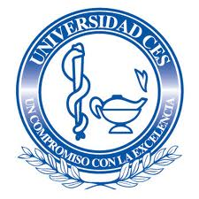

CES University is a national, independent, private, non-profit, self-sustaining organization that offers undergraduate and graduate programs, on the technological and professional level in all areas of knowledge, with the highest human, ethical and scientific attributes in a globalized world.

It goal has been to encourage an excellent formation of students and to achieve it, maintains a dynamic update of its curriculum, stimulates the self-education and permanent innovation, and has a highly staff qualified and committed to institutional development, which encourages all members of the University to achieve their personal, professional and institutional purposes.

CES University is ranked third in the Comprehensive Ranking of higher education institutions in Colombia, according to the study done by BOT Management Consultants in 2013. The study reviewed teaching, research and extension levels of the Universities nationwide. In each of these items, CES University reached very significant levels.

**1.2** **ACADEMIC AND SERVICE CENTERS:**

CES University has the following modern and spacious facilities, distributed throughout the city of Medellin:

* **ADMINISTRATIVE CENTER AND MAIN CAMPUS**:

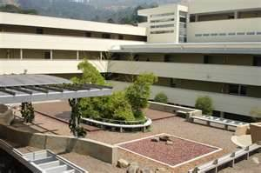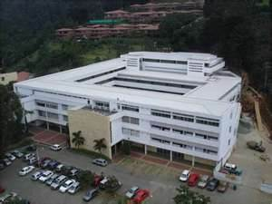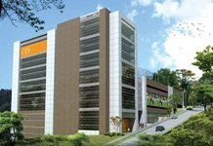

Located in El Poblado Calle 10 A # 22-04, in one of the most exclusive residential, financial and commercial areas of ​​the city.

In this campus are located the main administrative areas of the university, including: President´s office, Academic Management, Knowledge Management, International Relations Office, Alumni Office, University Welfare, Dean´s offices, etc. And this is the campus in which most lectures are held for undergraduate and postgraduate programs.

* **CES CLINIC:**

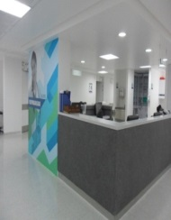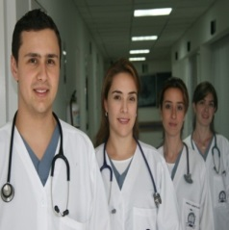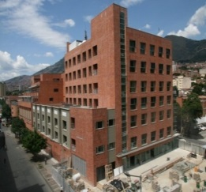

Located in downtown Medellin in Carrera 50C # 58-55 is strategically near the metro station and other public routes of transport.

Services**:**

* Emergency surgery
* Medical consults
* Cardiovascular Diagnosis
* Adult´s Hospitalization
* Pediatric´s Hospitalization
* Pathology Laboratory
* Radiology and Diagnostic Imaging
* Adult´s Intensive Care Unit
* Adult´s Intermediate Care Unit
* Cardiology Unit
* Emergency
* Dental Emergencies.

Special Services:   
Cardiology Unit, Wound Clinic, Pain Clinic and Minimally Invasive Surgery.

**CES SABANETA:**

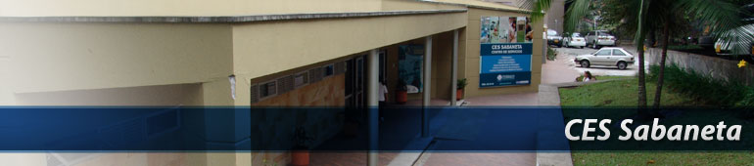

Located at Carrera 43 A # 52 South – 99 in Sabaneta.

CES Sabaneta is a service center that offers care in Dentistry, Medicine (Dermatology), Physiotherapy and Psychology.

It is the headquarter of the Colombian Institute of Tropical Medicine ICMT-CES and important laboratories that support research and teaching in: Biomechanics, Biomaterials Laboratory Hydrogels, Citer (Center for Rehabilitation Engineering and Technology) and Tissue Culture.

At this center, is also located the headquarter of Legal services that offers the Faculty of Law, which includes a Conciliation Center, and teaching units for care services, to provide legal advice in the various branches of law.

* **CES ALMACENTRO:**



Located on Carrera 43 A N. 34-095, Center for Specialized Dentistry.

CES Almacentro is a high quality human, scientific, and technical services unit, staffed by specialists in all the areas of dentistry with academic support from the dentistry faculty of the CES University.

It´s location allows easy and secure access for patients requiring specialized treatment not covered by the EPS:

Services:

• Prosthetics.

• Periodontics

• Endodontics

• Orthodontics

• Pediatric Dentistry

• Center for Craniofacial Anomalies

* **VETERINARY MEDICINE AND ZOOTECHNICS CENTER:**

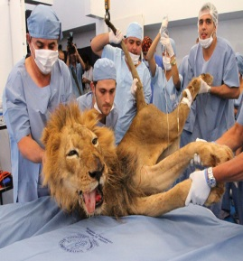

Located in Envigado: Calle 36 Sur Km 4 (Loma del Escobero)

The veterinary Medicine and Zoo technics center is a modern, state of the art teaching-assistance facility for our students and teachers of the livestock and agriculture areas. It is specifically designed to offer a variety of services including clinical care and hospitalization for large and small animal species, surgery, imaging center, vaccination, post-operation recovery rooms and others.

Its modern infrastructure has an appropriate information system, an assessment office, and operating rooms for large and small species with classrooms that are communicated through a closed television circuit system as well as a panoramic window for direct visualization. It also has a sophisticated pulley-elevated transportation system which can rotate animals in 360 degrees, and move them in and out of the examination devices connected to monitors that allow tissue viewing on an 18” screen, permanent oxygen supply and x-ray and ultrasound services.

The center also provides consulting services in different agro-technical areas such as animal health and reproduction, genetics, nutrition, soils, waters, environmental sanitation, waste-disposal and agro technical management.

Services:

• Service for small animals (dogs and cats.)

• Services for large species (horses and cattle)

• Diagnostic aids

• Agricultural Consulting

• Agricultural Warehouse

• Clinical Lab

• Operators of important projects for the community.

**COLOMBIAN INSTITUTE OF TROPICAL MEDICINE – CES “ANTONIO ROLDAN BETANCUR”:**

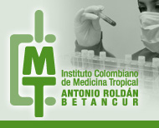

It’s a nonprofit research center distinguished internationally for its academic excellence. It has the COLCIENCIAS recognition as Grupo A1 “Institución de Excelencia en investigación” for its excellence in research and development.

It was founded in 1989 as a mixed corporation managed by CES University in association with the government of the state of Antioquia for social and public interests.

The institute has its head office located in Sabaneta inside the university campus at the southern area of the city and has joint activities with another facility located out of town in Apartado Antioquia.

* **CEMPAS (CENTER OF MEDICAL AND PARAMEDICAL TRAINING WITH SIMULATORS):**

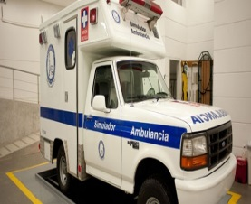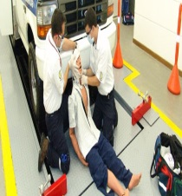

The Center for Medical and Paramedical training with Simulators –CEMPAS- offers the health sector and the academic community, training with the use of simulators in order to acquire skills and abilities for the management of emergency, urgency or disaster situations. It complements current training of undergraduate and postgraduate students and develops new strategies of continuing education for health personnel and other disciplines related with prevention and attention of emergencies and disasters.

The simulation is based on the use of the following resources:

* Visual or acoustic reproduction.
* 3D models.
* Written simulation exercises.
* Simulation by computer.
* Situations simulated with real people.
* Automated mannequins.

* **CENDES:**

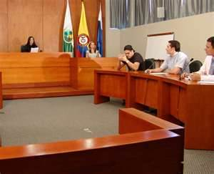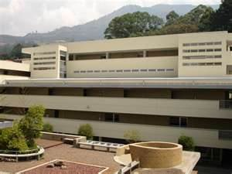

The judicial consulting services center CENDES belongs to the faculty of law and is the only one in Colombia that within a private university is in capacity to offer its expert opinion in terms of health sciences.

Its main propose is to protect the patients in case of any injury or omission of its rights at the moment of being treated. It also gives protection and defense means in case of any mental disease or illness caused by being the victim or victimizer involved in a conflict resolution process.

It also offers judicial counseling in case of facing a loss of labor capacity or being handicapped, dealing with labor injuries or having any occupational disability.

**1.3 INTERNATIONAL RELATIONS OFFICE:**

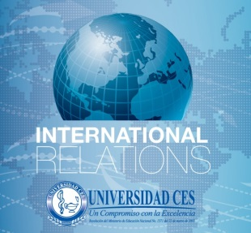

The international relations office at CES University was founded based on the necessity to understand the internationalization process as resource for increasing the academic quality of its programs, making it a more competitive institution that supports its members in the process of growing and expanding their vision in order to be better prepared for today’s globalized context.

The university has demonstrated the commitment to promote its involvement in the international community by signing agreements with foreign universities to give to its students, faculty employees and researchers, exchange opportunities to improve their professional background and performance.

One of the main objectives of the office is to strengthen the clerkship and exchange mobility with other universities in order to provide the international students with a very good offer of undergrad programs and at the same time learn from their culture and experience to build an open and multicultural environment.

With the support of the institutional policies and the directives at CES University for the internationalization, the university is expecting to become a worldwide organization recognized by the quality of its actions.

**Members of the International Relations Office:**

**Juan Jaime Arroyave Restrepo**  
Coordinator  
**Tel:** (574) 444 05 55 **ext.** 1371  
**E-mail:** [jarroyaver@ces.edu.co](mailto:jarroyaver@ces.edu.co) Esta dirección de correo electrónico está protegida contra spambots. Usted necesita tener Javascript activado para poder verla.   
**skype:** juanarroyave86

**Pablo Garcés Jaramillo**  
Monitor  
**Tel:** (574) 444 05 55 **ext.** 1612 **E-mail:** [pagarces@ces.edu.co](mailto:jarroyaver@ces.edu.co) Esta dirección de correo electrónico está protegida contra spambots. Usted necesita tener Javascript activado para poder verla.

**Carolina Palacio Restrepo**International relations Intern **Tel:** (574) 444 05 55 ext. 1635 **E-mail:** [cpalacior@ces.edu.co](mailto:cpalacior@ces.edu.co) Esta dirección de correo electrónico está protegida contra spambots. Usted necesita tener Javascript activado para poder verla.  Esta dirección de correo electrónico está protegida contra spambots. Usted necesita tener Javascript activado para poder verla.

**Mónica Alexandra Marín Fernández**  
Secretary  
**Tel:** (574) 444 05 55 **ext.** 1635 **E-mail:** [mmarin@ces.edu.co](mailto:mmarin@ces.edu.co) Esta dirección de correo electrónico está protegida contra spambots. Usted necesita tener Javascript activado para poder verla.  Esta dirección de correo electrónico está protegida contra spambots. Usted necesita tener Javascript activado para poder verla.

**You can follow us:**

E-mail: [cesinternacional@ces.edu.co](mailto:cesinternacional@ces.edu.co) Esta dirección de correo electrónico está protegida contra spambots. Usted necesita tener Javascript activado para poder verla.   
Facebook: [cesinternacional@ces.edu.co](mailto:cesinternacional@ces.edu.co) Esta dirección de correo electrónico está protegida contra spambots. Usted necesita tener Javascript activado para poder verla.   
Twitter: @CES_RRII

1. **MOBILITY PROGRAMS AT CES**

**2.1 PROGRAMS OFFERED FOR ACADEMIC MOBILITY AT CES UNIVERSITY**

**-** Biology

- Dentistry  
- Law

- Management Studies  
- Medicine

- Pharmaceutical Chemistry

- Physiotherapy

- Psychology

- Pre-Hospital Care Technology (Paramedic)  
- Veterinary Medicine and Zootechnics

**2.2 MOBILITY PROCESS**

CES University offers to the international students the possibility to participate as a fulltime student in any of its undergrad programs. It also offers a series of possibilities for graduate master and PhD students.

It has two types of programs:

* **ACADEMIC SEMESTER:** For students coming from foreign universities that have bilateral agreements with CES University. The students are able to participate as a fulltime student on an academic program.
* **CLERKSHIP AND ROTATION PROGRAM:** Offers to students the possibility to attend real life situations as an observer in practice environment through a one to three months period with or without having a bilateral agreement between their the institutions and CES University.

**In order to be eligible for these programs all international students must complete an online application at** <http://relacionesinternacionales.ces.edu.co/>.

* 1. **ACADEMIC CALENDAR**

All international students who are interested on participating in a mobility program should consider the dates of the academic calendar.

For participating on an academic semester program:

* First academic semester is from January 20th to June 20th. Nominations must be done before October 31 of 2014.
* Second academic semester begins in July 14th and ends in November 28th. Nominations must be done before July 15 of 2014.

For participating on a clerkship or rotation program:

Students can come at any time of the year in the dates of their choosing except during the holyday season from December 22th to January 20th. This also depends on the availability that each faculty has to receive a certain number of students per program. At any case it is mandatory to be nominated at least three months in advance.

**2.4. STUDENT VISA:**

All international students need to have a valid visa in order to complete their mobility program. They must get their visa at the Colombian consulate in their home country before entering national territory and do the request according to the time period that they are planning to stay in Colombia.

To get more information about visa types and required documents must follow: <http://www.ces.edu.co/index.php/visas>

1. **HEALTH INSURANCE AND IMMUNIZATIONS REQUIREMENTS:**

International students and professors who are willing to come and be part of a mobility program must have an international medical insurance prior to their arrival. It should cover any eventuality by accident, disease or death, during all the time that are intended to participate in the program. The University accepts various international insurance policies as long as they comply with the requirements listed below:

|  |  |
| --- | --- |
| **FACULTY** | **IMMUNIZATIONS REQUIREMENTS** |
| BIOLOGY | Hepatitis B, antibodies for Hepatitis B, tetanus, varicella antibodies, MMR. |
| DENTISTRY | Hepatitis B: The complete vaccination schedule with 3 doses.  Tetanus: The complete vaccination schedule with 3 doses and an updated reinforcement.  MMR: The complete vaccination schedule with 1 updated reinforcement. |
| LAW | Not required |
| MANAGEMENT STUDIES | Not required |
| MEDICINE | Hepatitis B, antibodies for Hepatitis B, Tetanus, varicella antibodies, MMR vaccine. |
| PHARMACEUTICAL CHEMISTRY | Hepatitis B, antibodies for Hepatitis B, Tetanus, varicella antibodies, MMR vaccine. |
| PRE-HOSPITAL CARE TECHNOLOGY (PARAMEDIC) | Hepatitis B, tetanus, varicella |
| PHYSIOTHERAPY | Hepatitis B, antibodies for Hepatitis B, tetanus, varicella antibodies, MMR vaccine. |
| PSYCHOLOGY | Hepatitis B, varicella antibodies, tetanus |
| VETERINARY MEDICINE AND ZOOTECHNICS | Hepatitis B, tetanus, yellow fever, diphtheria. Rabies vaccination is recommended but not mandatory. |

**3. STUDENT SERVICES**

**3.1 UNIVERSITY ID.**

It is assigned to all exchange students, which should be carry permanently on the premises of the University. The card allows access to all the services of the institution.

**3.2 UNIVERSITY INDUCTION**

Before beginning your academic rotation or internship, you must go to the office of international relations to have a welcoming and orientation to meet the main campus and the university facilities, in order to identify the location of certain offices like the wellness center and library. Then students are introduced to the faculty coordinator in charge of their mobility program.

**3.3 INTEGRATION PROGRAM FOR INTERNATIONAL STUDENTS:**

The office of International Relation and Wellness Center organize a series of activities around the city in which all international students can participate without paying any fee. Information about the activities dates and schedule can be found at the university web page in the international relations link: <http://www.ces.edu.co/index.php/noticias/240-relaciones-internacionales/internacionalizacion-en-casa/704-eventos>

**3.4 LIBRARY SERVICES:**



The university “founder’s library” located inside the Poblado campus has specialized documents and access to international research data bases that support the academic development of the entire community.

**3.5 COMPUTER ROOMS:**

The university has free access to several computer rooms across the main campus and library with internet access.

**3.6 WIRELESS NETWORK:**

The University has free access to Wi-Fi service inside the campus.

**3.7 CES SHOP:**

The University has its own shop where you can buy all institutional items including books and uniforms.

**3.8 PHOTOCOPY AND SCANNER CENTERS:**

The University has within its facilities multiple service points to photocopy and scan documents.

**3.9 DINNING SERVICES:**

The University offers snack shops and food courts inside its facilities.

**3.10 SPORTS, PHISICAL EDUCATION AND CULTURAL ACTIVITIES:**

The University offers to all of its students multiple sports options and cultural activities where they can participate.

You can contact the recreation and Wellness Center to find out more about sport options and recreations, at: <http://www.ces.edu.co/index.php/universidad-ces/bienestar-universitario/presentacion-bienestar-universitario>



**4. ADITIONAL INFORMATION:**

**4.1 HOW TO GET TO CES UNIVERSITY.**

The main campus and headquarters of CES University is located in “El Poblado” on Calle 10 A No. 22 – 04.

It is possible to get there by the following ways:

• Taxi

• Metro: Stop at the Poblado station where is possible to take the bus (route 134) service integrated path.

• Bus: bus metro route, San Lucas 136 route and “comercial hotelera” route.

**4.2 HOUSING INFORMATION:**

All housing options are off-campus. However the office of International Relations provides information about different lodging options.

All international students are free to choose the place where they want to stay during their visit and it’s not necessary to contract with one of the places THAT THE International Office recommends. (These are only recommendations since CES University doesn’t have any agreement with them and is not responsible for any contingencies that may arise between the student and the accommodation place).

**4.3 COLOMBIA:**

It is a unitary, constitutional republic comprising thirty-two departments. It is located in northwestern South America, bordered to the northwest by Panama; to the north by the Caribbean Sea; to the east by Venezuela and Brazil; to the south by Ecuador and Peru; and to the west by the Pacific Ocean.

The territory of what is now Colombia was originally inhabited by indigenous peoples including the Muisca, Quimbaya, and Tairona. The Spanish arrived in 1499 and initiated a period of conquest and colonization ultimately creating the Viceroyalty of New Granada, with its capital at Bogotá. Independence from Spain was won in 1819, but by 1830 "Gran Colombia" had collapsed with the secession of Venezuela and Ecuador. What is now Colombia and Panama emerged as the Republic of New Granada. The new nation experimented with federalism as the Granadine Confederation (1858), and then the United States of Colombia (1863), before the Republic of Colombia was finally declared in 1886. Panama seceded in 1903.

Colombia was the first constitutional government in South America, and an important promoter of the Pan American organizations, initially through the Congress of Panama and later as founder of the Organization of American States. Colombia was engulfed in the Year-Long War with Peru over a territorial dispute and entered the Korean War as an ally of South Korea. Since the 1960s, the country has suffered from an asymmetric low-intensity armed conflict. The conflict escalated in the 1990s, but since 2000 the conflict has decreased considerably.

Colombia is very ethnically diverse, and the interaction between descendants of the original native inhabitants, Spanish colonists, Africans originally brought to the country as slaves, and 20th-century immigrants from Europe and the Middle East, has produced a rich cultural heritage. This has also been influenced by Colombia's varied geography, and the imposing landscape of the country has resulted in the development of very strong regional identities, in many cases stronger than the national. The majority of the urban centers are located in the highlands of the Andes mountains, but Colombian territory also encompasses Amazon rainforest, tropical grassland and both Caribbean and Pacific coastlines.

Ecologically, Colombia is one of the world's 17 mega diverse countries, and is considered the most mega diverse per square kilometer. Colombia is a middle power with the third largest economy in South America, and is part of the CIVETS group of six leading emerging markets. Its principal industries include food processing, textiles, clothing and footwear, chemicals, beverages, cement, coffee, sugarcane, oilseed and other agricultural products, forest products, cut flowers, processed fish products, emeralds, plastics, Ferro-alloys, coal, gold, oil, nickel, financial services and the automotive industry.

**4.4 MEDELLÍN:**

Officially the Municipio de Medellín (Spanish for Municipality of Medellin), is the second-largest city in Colombia. It is in the Aburrá Valley, one of the most northerly of the Andes Mountains in South America. As of 2012, it has a population of 2.7 million. With its surrounding area, the metropolitan area of Medellin (area metropolitan de Medellin), which includes nine other cities; it is the second largest urban agglomeration in Colombia in terms of population and economy, with more than 3.5 million people.

Medellin was founded in 1616 by the Spaniard Francisco Herrera Campuzano as Poblado de San Lorenzo (Saint Lawrence Town) in present-day El Poblado. In 1675 the queen consort Mariana of Austria created the Villa de Nuestra Señora de la Candelaria de Medellin (Town of Our Lady of Medellin).

In 1826 the city was named the capital of the Department of Antioquia by the National Congress of the young Republic of Greater Colombia (Gran Colombia), comprised by present day Colombia, Venezuela, Ecuador and Panama. After Colombia won its independence from Spain, Medellin became the capital of the Federal State of Antioquia until 1888, with the proclamation of the Colombian Constitution of 1886. During the 19th century, Medellin was a dynamic commercial center, first exporting gold, then producing and exporting coffee.

At the beginning of the 21st century, the city has regained industrial dynamism, with the construction of the Medellin Metro commuter rail, and liberalized development policies, improved security, and improved education. Researchers at the Overseas Development Institute have lauded the city as a pioneer of a post-Washington consensus 'local development state' model of economic development. The city is promoted internationally as a tourist destination and is considered by the GaWC as sufficient to be a global city.

The Medellin Metropolitan Area produces 67% of the Department of Antioquia's GDP and 11% of the economy of Colombia. Medellin is important to the region for its universities, academies, commerce, industry, science, health services, flower-growing, festivals and nightlife.

In February 2013, Medellin was chosen as the most innovative city in the world due to its recent advances in politics, education, and social development. In the same year, Medellin was announced as the preferred corporate business destination in South America and won the Veronica Rudge Urbanism Award conferred by Harvard University to the Urban Development Enterprise, mainly due to the North-Western Integral

**4.5 MONEY MATTERS:**

**CURRENCY:**

The official currency of Colombia is the Colombian peso. To find out more about the Colombian money market you can go to:

<http://www.colombia.travel/es/turista-internacional/informacion-practica/convertidor-de-moneda>

**4.6 BANKS AND BANK ACCOUNTS:**

There are a big number of important banks located in Medellin including:

CORPBANCA (CES University has an in campus office), BANCOLOMBIA (CES University has several ATMs in its facilities), DAVIVIENDA, CITIBANK, BANCO DE BOGOTA, BBVA, HSBC, COLPATRIA, HELM, etc.

To obtain a bank account it is necessary to have a foreign ID card (this ID will be given to foreigners, older than 18 years of age, who are holders of a visa permit for more than 3 months which must be processed once in Colombia and given by the Colombian immigration office located in Calle 19 80 A-40 Medellin.

**4.7 TRANSPORTATION:**

**AIRPORTS:**

Medellin has to airports. One for domestic flights and another for international flights.

* **José María Córdoba International Airport:**

It is located out of town in the Rionegro area. It is possible to get there by public or private transport taking the Santa Elena route, Las Palmas route or using the Medellin-Bogotá highway.

The international relations office offers the contact number of a transport service that goes and comes to the airport at a cost of 67.000 COP (33.00 USD)

Rubén García. Cel: 3137437726 - Ruby Arango. Cel: 3137438963

There is also possible to find taxi and bus services to go from the airport to the city area outside the airport. Their approximated cost is 65.000 COP (32.50 US) for a taxi service and 10.000 COP (5.00 US) for bus.

* **Olaya Herrera airport:**

It is located at the south east area of the city. It offers domestic flights to all regions in Colombia and is considered as one of the most important regional airports in the country.

**MEDELLIN METRO SERVICE:**

This transport system is used by around 3.500 people every day and has different metro lines that cross the city.

* line "A" for north south area
* Line “B” for downtown and east area.
* Line k or cable car for northwest area.
* Line j or cable car for east area.

**OPEN HOURS AND COSTS:**

The complete system provides commercial services from Monday to Saturday, between 4:30 am to 11:00 pm. Sundays and holidays lines A and B are open from 5:00am to 10:00pm. Lines k and j of metro cable provide services from 9:00am to 10:00pm

|  |  |
| --- | --- |
| **Ticket** | **value** |
| Using Civic card for "Frequent" user | $1,650 - US 0.81 |
| Travel with civic card "to the carrier" | $1,700 - US 0.84 |
| Students | $1,350 - US0.66 |
| Older adults | $1.570 = US0.77 |
| Handicapped | $1.390 = US0.68 |
| Single trip | $1.900 = US0.94 |

The metro service works jointly with integrated bus lines around the city. To know the availability of routes you can go to the Metro webpage:[**http://www.metrodemedellin.gov.co**](http://www.metrodemedellin.gov.co)

In Medellin there is also the Metroplús service which is a bus system powered by the metro company to supply additional transport coverage in other areas of the city which are not close to metro stations. Find out more at[**http://www.metroplus.gov.co**](http://www.metroplus.gov.co/)

**BUSES:**

The city counts with many public and private buses and microbuses.

You can buy the ticket to get in, directly to the driver.

Prices:

Bus: $1.700 = US 0.85

Microbus: $1.800 = US 0.90

**TAXI CABS:**

The city counts with more than 22.000.

All the taxis are painted yellow, for an easy recognition. Medellin taxi service has almost the half of all the vehicles of the city making it easy to find a taxi at any time.

Many taxi companies have an English service for foreigners.

**BUS TERMINALS:**

In Medellin Buses terminals offer commercial and shopping options inside their facilities.

• **North Area Bus Terminal:**

It’s located in the northwest area of the city in the Caribe neighborhood. It is possible to get there by metro stopping at the Caribe station. It offers bus routes to go to the east and north cities of the country.

* **South Área BusTerminal:**

It’s located in the southwest area of the city in the Guayabal neighborhood. It offers bus routes to go to the southern cities of the country.

* 1. **COLOMBIAN FOOD AND GASTRONOMY:**

Colombia has a very varied cuisine with particular characteristics that change from region to region depending of their cultural background.

Some of the main dishes are:

* **Bandeja paisa:** it’s traditionally found in the Antioquia area and is made with beans, ground beef, rice, plantain, chorizo, arepa and hogao that are very traditional ingredients in the Colombian gastronomy.
* **Mondongo:** it’s a traditional soup made with pork keys and pork beef seasoned with coriander.
* **Sancocho:** it’s a chicken soup served with potatoes and plantain.
* **Arepa:** it’s a corn bun used as accompaniment for several dishes and is usually served with cheese and hogao.
  1. **WHAT TO DO IN MEDELLIN:**

Medellin is a very beautiful city which is constantly growing and expanding where is possible to find new places and things to do every day.

It has a combination between old and modern, urban and rural architecture which gives it a very unique and characteristic environment.

Some of the most touristic places to visit are:

Parque Explora and its aquarium, Cerro Nutibara (Pueblito paisa), La Plazoleta de las esculturas (Plaza Botero), Centro de espectáculos la Macarena, Jardín Botánico, Parque Lleras, Santa Fe Zoo, metropolitan catedral, Centro Administrativo La Alpujarra “José María Córdova”, Museo de Antioquia, Museo El Castillo, Palacio de la Cultura “Rafael Uribe Uribe”, Parque Arví and Plaza Cisneros - Parque de la Luz.

To find out more about Medellin and tourist information go to**:** [www.guiaturisticamedellin.com](http://www.guiaturisticamedellin.com)

**SHOPPING MALLS:**

Medellin has plenty of shopping malls and stores becoming a perfect city for shopping and having fun with friends enjoying the great offer of recreational options of each of these sites.

|  |  |
| --- | --- |
| **MALL** | **ADRESS** |
| Parque Comercial El Tesoro | Carrera 25A No. 1A Sur-45 |
| Oviedo | Carrera 43A No. 6Sur-15 |
| Sandiego | Calle 34 No. 43-66 |
| Santa Fé | Carrera 43 A 7 S-130 |
| Centro Comercial Terminal  del Sur | Carrera 65C No. 8B-91 |
| Palacio Nacional | Carrera 52, Carabobo entre las  calles 49, Ayacucho y 48 |
| Terminal del Norte | Carrera 64C No. 78-580 |
| Unicentro | Carrera 66B No. 34A-76 (Avenida Bolivariana) |
| Obelisco | Carrera 74 No. 48-37. Piso 8,  oficina 811 |
| Punto Clave | (574) 261 15 36 Carrera 48 27-24 |
| Los Molinos | Carrera 82 31A-05 |
| El Diamante | Calle 51 No. 73-120 |
| Camino Real | Carrera 47 No. 52-86 |
| Monterrey | Carrera 48 No. 10-45 |

**HOLIDAYS AND FESTIVITIES:**

* January 1 new year
* January 6 three kings day *
* March or April (2 days) Thursday and good Friday - Easter
* March 19-Saint Joseph's day *
* May 1-labor day
* May day of the Ascension of the Lord (variable) *
* May or June Habeas Corpus Christi (variable) *
* June 29 St. Peter and St. Paul *
* June-Sacred Heart (Variable) *
* 20 July independence day
* Battle of Boyacá 7 August
* August 15 assumption day *
* October 12 discovery of America *
* November 1 All Saints departed day *
* November 11-independence of Cartagena *
* December 8 immaculate conception day
* December 25 Christmas

Signaled days will be celebrated the next Monday according to the emiliani law to promote tourism.

* 1. **CLINICS AND HOSPITALS:**

|  |  |
| --- | --- |
| **NAME** | **ADRESS** |
| Clínica Ces | Carrera 50 C No. 58-55 |
| Clínica Medellín - Poblado | Calle 7 No. 39-290 Avenida El Poblado |
| Clínica Las Vegas | Calle 2 sur No. 46-55 |
| Clínica Medellín - Centro | Calle 53 No. 46-38 |
| Clínica Las Américas | Carrera 80 diagonal 75B- # 2 A-80 |
| Clínica El Rosario | Carrera 41 No. 62-05 |
| Clínica De Fracturas De Medellín | Carrera 45 No. 53-38 |
| Hospital General de Medellín Luz Castro de Gutiérrez | Carrera 48 No. 32-102 |
| Clínica Soma | Calle 51 No. 45-93 |

* 1. **FACTS ABOUT COLOMBIA AND CULTURAL DIFFERENCES:**
* **Security:**

After several years of armed conflict the Colombian government has managed diminish the insecurities and inequality that was affecting the Colombian citizens in the past.

This is why now days we can live in a safe place where visitors and locals are allowed to enjoy all the good things that Colombia has to offer.

The Colombian economy has also proven to be one of the most stable ones in Latin America making it a very good destination for foreign direct investment and business opportunities.

* **Culture:**

In Colombia it is possible to find a big variety of ethnicities and cultural backgrounds that make it a very diverse country recognized by the kindness of its people who make feel any foreigner just as another Colombian.