

**For more information contact:**

Christina Rozario at 732-235-8254 or rozaricum@rutgers.edu

**For shuttle service schedule visit:** rudots.rutgers.edu

Scroll down to transportation section and click on *RBHS Hospital Schedule*

**Topic:**

Promoting Health Equity and Humanism – Local to Global

**Date and Time:**

Thursday, December 10, 2015

5:30 PM

**Location:**

Arline and Henry Schwartzmann Courtyard

Robert Wood Johnson University Hospital

One Robert Wood Johnson Place

New Brunswick, New Jersey

**Hosted by the** Office of Global Health

*Light Refreshments will be served.*



***Part of Rutgers, The State University of New Jersey***

Annual Global Health Fair

In Collaboration with Rutgers Centers for

Global Advancement and International Affairs



**Keynote Speaker**

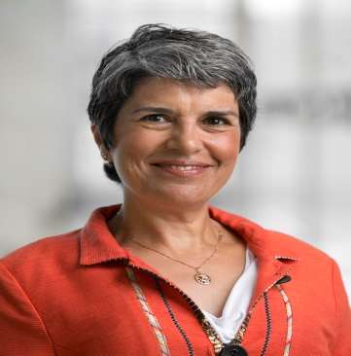

**Cynthia Haq, MD**

Professor of Family Medicine

And Population Health Sciences

University of Wisconsin

School of Medicine and Public Health

Madison, Wisconsin