Bassel Bashjawish
Global Health Trip: Taiwan 2015

In the summer of 2015, I traveled with two fellow classmates to the capital of Taiwan, Taipei, for a 4-week global health exchange program. The first of its kind at Robert Wood Johnson, the goal of this program was to learn more about the healthcare issues Taiwan faces being a country with national healthcare. During our trip, we were also given an invaluable look into how traditional Chinese (Eastern) medicine, a form of medicine with roots stretching back thousands of years, is incorporated into modern healthcare practices.

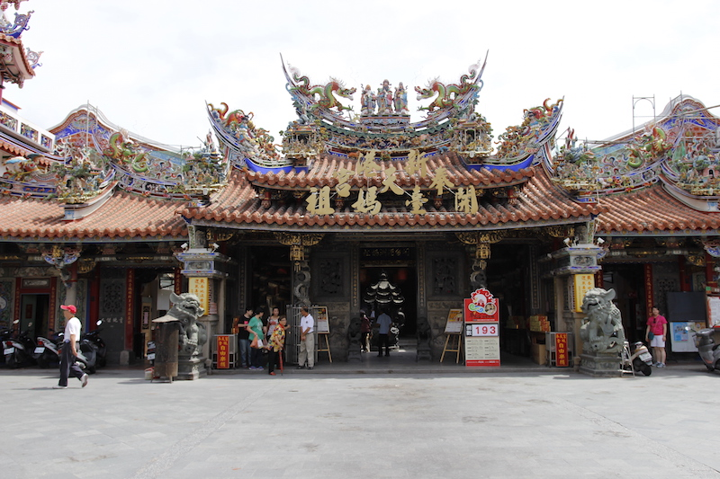
Our formal trip began after a 2-hour high-speed train ride from the northern capital, Taipei, to a small city in the southwestern region of the island known as Chiayi (Jiayi). A demographically unique town, Chiayi is a model representation of where community medicine is most effective; over 65% of the inhabitants of Chiayi are over the age of 65. The promise of high paying jobs and the excitement that city life brings draws many young Taiwanese men and women from the rural regions, leaving their elderly parents behind to take care of themselves. This did not leave them hopeless, however. Frequently during the 4 days we were in Chiayi, we met cheerful elderly couples walking down the streets, praying in the various temples erected to different Gods, and even practicing TaiQi at night when the weather was less unbearable.

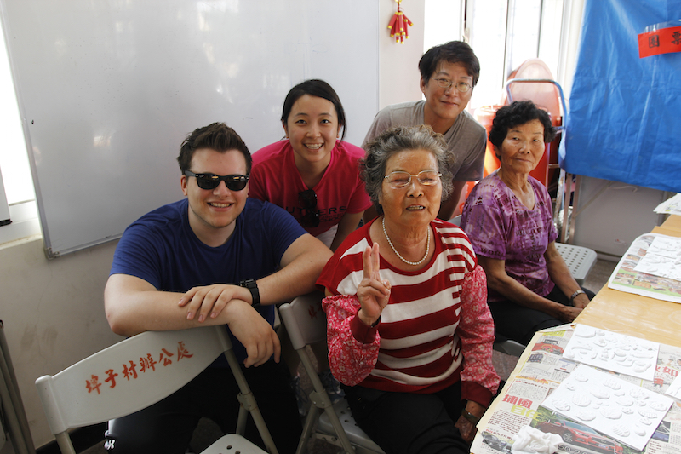
Through National Taiwan University in Taipei and a local non-profit organization based in Chiayi, the Xingang Foundation, we were introduced to the different the Foundation provides assistance and community medicine to its elderly population. My most memorable experience with the Xingang Foundation was preparing hot, nutritious meals and delivering them on motorized scooters to those in the community who are non-ambulatory. I was touched by the number of volunteers who worked tirelessly to ensure these members of the community never felt disconnected or left behind; this was when I was introduced to the term “filial piety”, a virtue of respect for one ‘s family and elders that originates in Confucian philosophy. The people of Chiayi felt a moral obligation to care for their less fortunate community seniors. Local restaurants were providing the food we were preparing and delivering free of charge. This was something that was uncommon in Western society, especially in large metropolitan areas, the duty to care for those in need at your own personal expense.

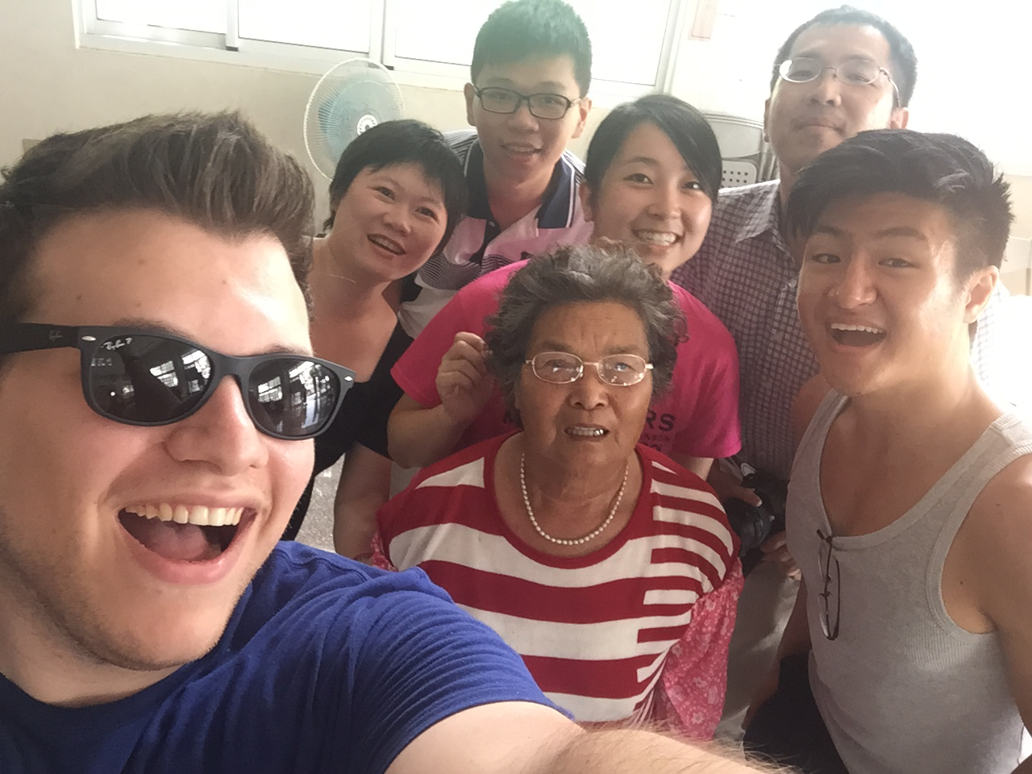
On our last day in Chiayi, we visited a community center that had been turned into a one-stop medical evaluation center complete with 3 large coach buses that were retrofitted with state-of-the-art medical imaging equipment such as X-ray machines to perform mammograms, abdominal and chest X-rays, ultrasound machine, and a simple blood diagnostics lab. Within the community center, doctors with different specialties set up booths and treated patients who came to see them for their respective maladies. Knowing that being evaluated by one physician is not fun, let alone a dozen, the community center tried to entertain them with a karaoke machine and provided free haircuts as incentives to bring the elderly patients out of their homes and help them get the treatment they need and socialize with others in their community. The community center provides an invaluable service to their residents, many of whom would not have received medical care for their chronic health conditions if the program was defunded. This, along with countless other community outreach programs that help bring the residents out of their homes and engaged in social events, is how the mayor of Chiayi and Taiwan serve their people.
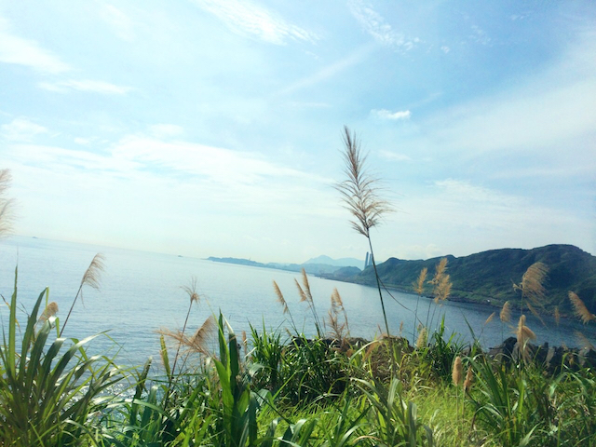
After returning to Taipei, we continued in our theme of community medicine by visiting different community centers and listening to their directors explain to us how they work to bring their community together and foster an environment of mutual respect and entertainment. Towards the end of our second week, we traveled to a mountainous region in the outer limits of Taipei called JinShan, or “Golden Mountain”, aptly named for the gold that was mined there in the past. In cooperation with the hospital in JinShan, we traveled with a physician to check on his patients, which he does twice per month. An area similar to Chiayi, the people in JinShan lack constant professional medical care and are at a higher risk of complications from chronic medical conditions simply because the nearest hospital is very far away. Many of the residents in JinShan rely on the help of a live-in nurse to take care of them.

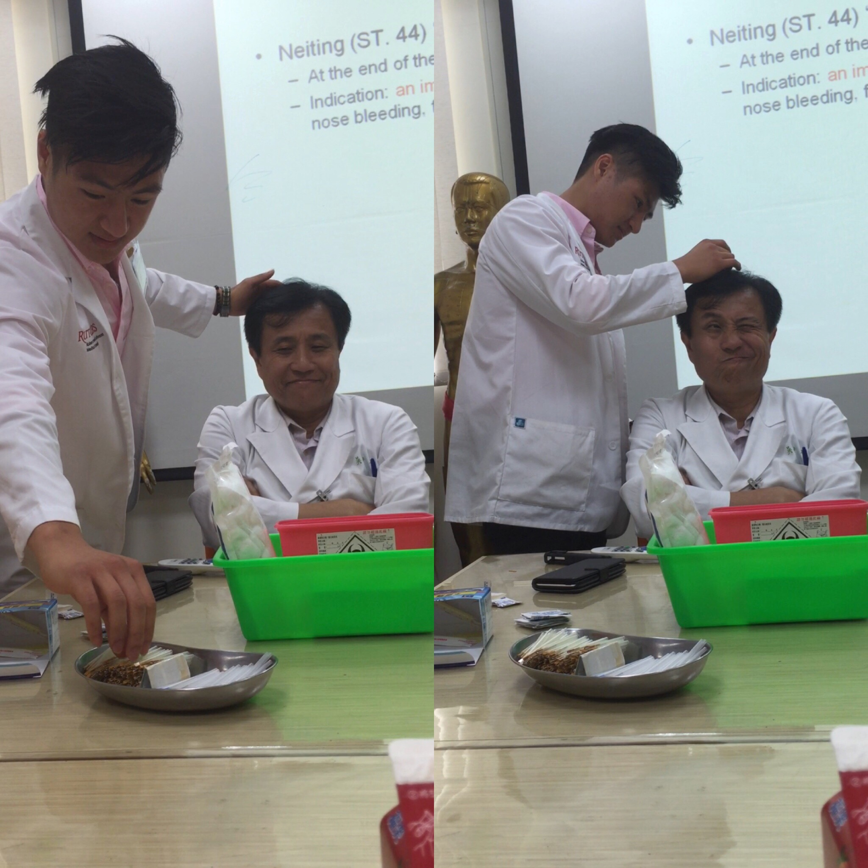
Our third week began with a subway ride to the Shipai district of Taipei where Veteran’s General Hospital is located and where would spend the remainder of our trip learning about traditional Chinese medicine, namely acupuncture. A cornerstone of Eastern medicine, acupuncture has become very popular in Western society as an alternative method of treatment when patients believe Western medicine has failed them. Training to become a specialist in traditional Chinese medicine requires 7 years of medical school to master all 364 points, their uses, and the named meridians they fall under, which is no easy feat.
As a medical student from the United States taught to practice evidence-based medicine, where scientific research and publications in peer-reviewed journals provide the evidence we need to call the outcomes of a treatment “statistically significant”, it was challenging reconcile idea of Qi because, in its essence, Qi is not testable. Qi, or the energy that makes up and flows through the body, forms the basis of Eastern medicine. Eastern medicine had long since developed their theories around the idea that an illness was an imbalance of a dichotomous energy system we know as yin and yang (dark and bright) before Western medicine came about. With the advent of the microscope, bacteria and parasites could be visualized for the first time and the theories of illness revolving around infection from microorganisms developed. A multifaceted and complex idea, yin/yang postulates that disease can be brought on by a loss of one energy or an abundance of the other; acupuncture sets out to physically manipulate the flow of Qi to correct this by using different motions with the insertion of the needle as well as insertion into specific points on yin/yang meridians. Under the instruction of the attending physicians in VGH’s traditional Chinese medicine clinic, we learned about the basic concepts of acupuncture and how meridian lines often followed the paths of “trigger points” over large peripheral nerves, neurovascular bundles, mechanoreceptors, and neuromuscular attachments. The overlap of meridian lines to anatomical structures indicated there was a way to scrutinize Eastern medical practices by Western medical standards, however research trials have shown that the effect in alleviating pain from acupuncture can be largely attributed to the placebo effect.

It was a privilege to travel to Taiwan and learn about the standard of care from the medical students and physicians. Although the country has a national healthcare system, what is seen as a “shining beacon” in the United States, it is not without its shortcomings. Payment for national healthcare comes largely out of the salaries of the healthcare professionals, who often see over one hundred patients before noon just to earn a living. Moreover, patients are given the choice to see as many doctors as they want, frequently seeing physicians when they are unhappy with the results they received from the previous doctor they visited. This leads to an enormous waste of time and resources since physicians cannot see a patient’s medical record unless they go to a hospital within the same network. Taiwan has begun to address the problem with the proposal of a “chip” installed into their national ID card that would carry their doctor visit history and show physicians what diagnostics were performed on them recently. Though Taiwan has some time to go before they can fix the pitfalls in their system, we can use their healthcare model to anticipate problems in setting up our own national healthcare system which forces people to pay exorbitant amounts set by private insurance companies that are turning healthcare into a business.

