Anita Ganti
Global Health Trip Summary
Ecuador-2014

This past summer I was given the opportunity to travel to Quito, Ecuador. My goals for this travel abroad experience included furthering my medical education by learning, practicing, and applying my clinical skills in a new environment and gaining international health exposure that may be helpful in better serving diverse populations. I also wanted to develop a better command of the Spanish language, especially in the medical context and immerse myself in a different culture in order to explore different customs and social practices. Finally, I wanted to understand how a healthcare system in a different country works in order to compare it to our own.
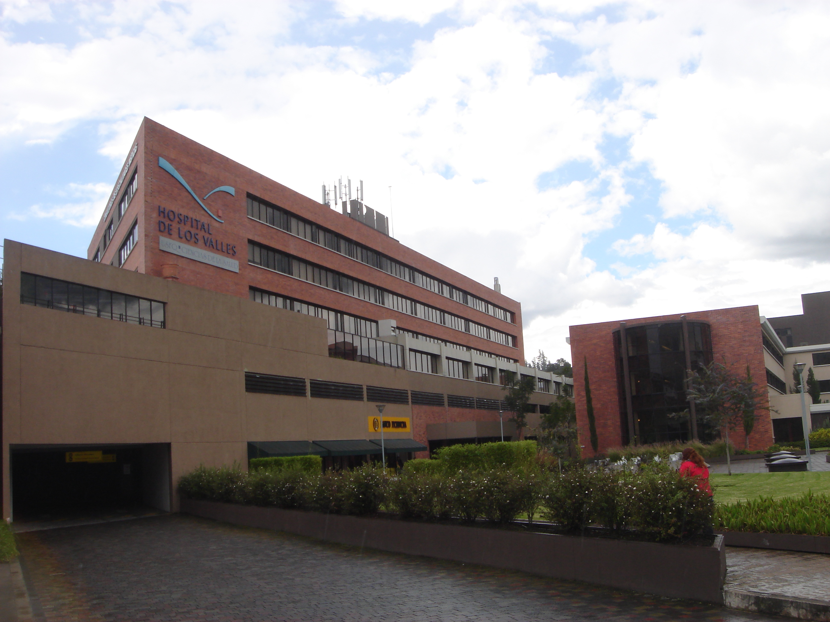

This was a cultural immersion experience as well as an educational experience in terms of learning Spanish and practicing clinical skills. In the mornings, we had medical Spanish classes where we spent some time learning the language as well as information about Ecuadorian culture. In the afternoons, we spent time at the Hospital de los Valles, the University Clinic, and a more rural clinic in Tumbaco. At these various clinic sites, we spent some time interviewing patients in Spanish, practicing physical exam skills, and presenting cases in both Spanish and English. We also travelled to a rural school and performed vision screenings for elementary school children Additionally, we had the opportunity to visit a medical museum with our professors and learn about the history of medicine in Ecuador. We stayed with local host families who took us around the city and taught us about local customs. In our free time and during the weekends, we had the opportunity to travel throughout the country and visit Banos, Guayaquil, and other tourist attractions like el Mitad de Mundo and el Panacillo. Ultimately, during my time in Ecuador I was able to practice my clinical skills as well as explore a new country and the diversity it had to offer.

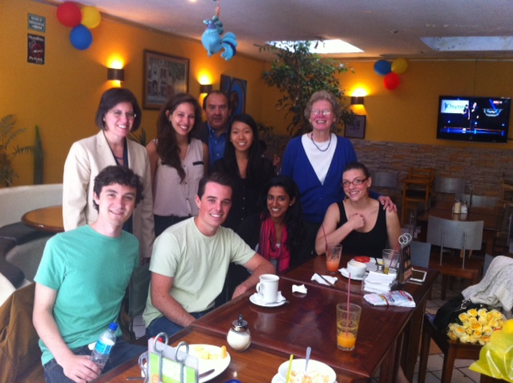
From my time in Ecuador, I learned that, especially in more rural areas, physicians heavily rely on history and physical exam findings in order to make a diagnosis. I appreciated the efforts made by the government and local organizations to provide healthcare to rural areas, specifically through free gynecological screenings for women at a rural clinic and the vision screenings at the rural elementary school. I also learned that here is stratification in the care that people receive based on their socioeconomic status. Finally, there is much to be learned about medicine from travelling to another country and I look forward to pursuing another global health elective during my third and fourth year rotations.

