A GLOBAL HEALTH EXPERIENCE IN UGANDA

COURSE NUMBER MDC 9070A
LOCATION: Kaberamaido, Uganda
ELECTIVE DIRECTOR: Karen W. Lin, MD, (karen.weiru.lin@rutgers.edu)
ELECTIVE FACULTY: Terri A. Nordin, MD, (terri.nordin@rutgers.edu)

BLOCKS AVAILABLE: Varies, block 7 for 2016

DURATION/WEEKS: MIN: 2; MAX: 4
HOURS PER WEEK: 40
STUDENTS: 2-3
LECTURES/SEMINARS: YES
OUTPATIENT: YES
INPATIENT: Possible
HOUSESTAFF: Possible
NIGHT CALL: NO
WEEKENDS: Yes, while traveling.
LAB: NO
EXAM REQUIRED: NO

OVERALL EDUCATIONAL GOAL OF ELECTIVE (from Global Health Programs website)
A global health experience to enhance
- awareness on international issues relevant to health,
- exposure to other languages and cultures, and
- knowledge of other health care systems.

Kaberamaido, Uganda (Dr. Terri A. Nordin, Assistant Professor of Family Medicine and Community Health)

OBJECTIVES
1. Those of the regular clinical outpatient training for medical students, including enhancing the six core competencies described below.
2. Enhancing cultural sensitivity and competence in medical students.
3. Encouraging these students to consider global health careers or practice in communities where there is a shortage of linguistically and/or culturally competent providers.

Patient Care: Students will be involved in direct patient care experiences with patients in rural Uganda. Through these experiences, students will gain knowledge of infectious diseases and other problems common to African populations and will learn how to provide culturally competent care to these patients. They will learn about practicing with limited resources and will get exposure to other systems of care.

Medical Knowledge: Students are expected to review didactic materials throughout the rotation that evaluate clinical topics encountered and global health issues.

Practice-Based Learning & Improvement: Students will be expected to be active independent learners, reviewing didactic materials and incorporating concepts in literature and clinical experiences in continued patient care. They are also expected to develop a scholarly project.

Professionalism: Students will demonstrate attitudes and behaviors that are professional and attentive to the patient's culture and their medical, psychological, and social well-being.

Interpersonal & Communication Skills: Students will develop interpersonal and communication skills that result in effective interactions with patients from other countries and cultures that may speak other languages.

Systems Based Practice: Students will work collaboratively with other professionals in community settings. Through this collaboration, students will understand how health services are provided in other health care systems.

BRIEF DESCRIPTION OF ACTIVITIES
Global Health Electives will be offered in several countries and will follow the guidelines outlined above. Some
countries may offer some unique experiences and these will be spelled out in an Appendix to this document.
For example, for some students, Medical Spanish would become a primary goal in the international rotations.
Others may like to learn about international research collaborations, etc.

Approved by Curriculum Committee 2/17/10
Experiential Component (Clinical)
This includes working in primary care clinics, hospitals, and community settings under the supervision of a RWJMS faculty physician. Students will assess the cultural and environmental context in which patients present and elicit the needed information on the subject’s medical, social, and personal condition; making or updating a diagnosis;
deciding and applying interventions; properly recording information on the encounter. After the clinical time, case discussion will be held with the supervisor.

Scholarly Project (Review Project or Case Presentation Project)
At the beginning of the elective, the student will agree with the mentor on a scholarly project. The project could involve a case presentation or a literature review, 4-6 pages, double spaced. The case presentation, besides the standard sections, should include a discussion of global health issues affecting the presentation, treatment,
and prognosis of the case. The literature review must deal with a subject relevant to Global Health in the specific region chosen for the elective. It can also include contrasts and comparisons between the US and the host country’s health care systems and lessons learned that can be applied here. In order to receive credit, students will also be required to complete a student feedback form about their learning experience at the global health site.

METHOD OF STUDENT EVALUATION
The evaluation will follow the general parameters in use at the school and will be completed by the RWJMS faculty member that includes:
- Attendance
- Knowledge
- Rapport/Communication/Professionalism
- Scholarly project

Are there any prerequisites for this elective? No

Is this elective available to third year medical students as well? Yes
UGANDA—Children’s HopeChest Kaberamaido CarePoint
Each year there is a team traveling to Eastern Africa to provide medical services and public health education to the community of Kaberamaido in Uganda (exact dates vary). Uganda has 2.7 million orphans and 44% of those orphans lost parents to AIDS. This experience is a chance for medical students and/or residents to provide care to a disadvantaged population of orphaned children and their caregivers. We focus on promoting primary care and teaching principles that will help the children become and remain more healthy.

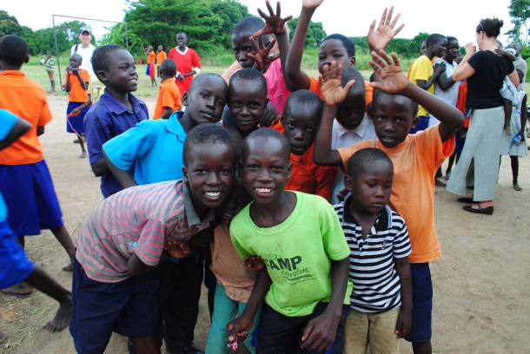
(Group of children from the CarePoint.)

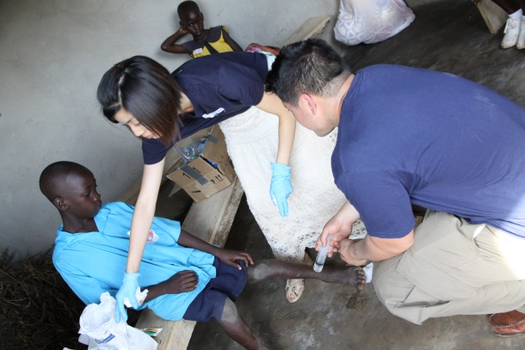
(Volunteers cleaning and dressing wounds.)
(Dr. Nordin rounding with the local medical officer.)
(Dr. Nordin performing screening exams.)

- Medical clinic at orphan care center (called a “CarePoint”) associated with Children’s Hopechest—primary care and acute care issues
- Provide health screenings for children of the CarePoint (~145 children ages 5 – 17)
- Provide health screenings for caregivers of the children of the care point
- Perform history and physicals on the children and their caregivers
- Provide educational counseling & teaching to the children and their caregivers
- Observe care at a local hospital
- Stay in guest house
- All meals provided
- Max 2-3 students
- Cost is approximately $2,000 (includes airfare, visa, ground travel, food, lodging, insurance)

