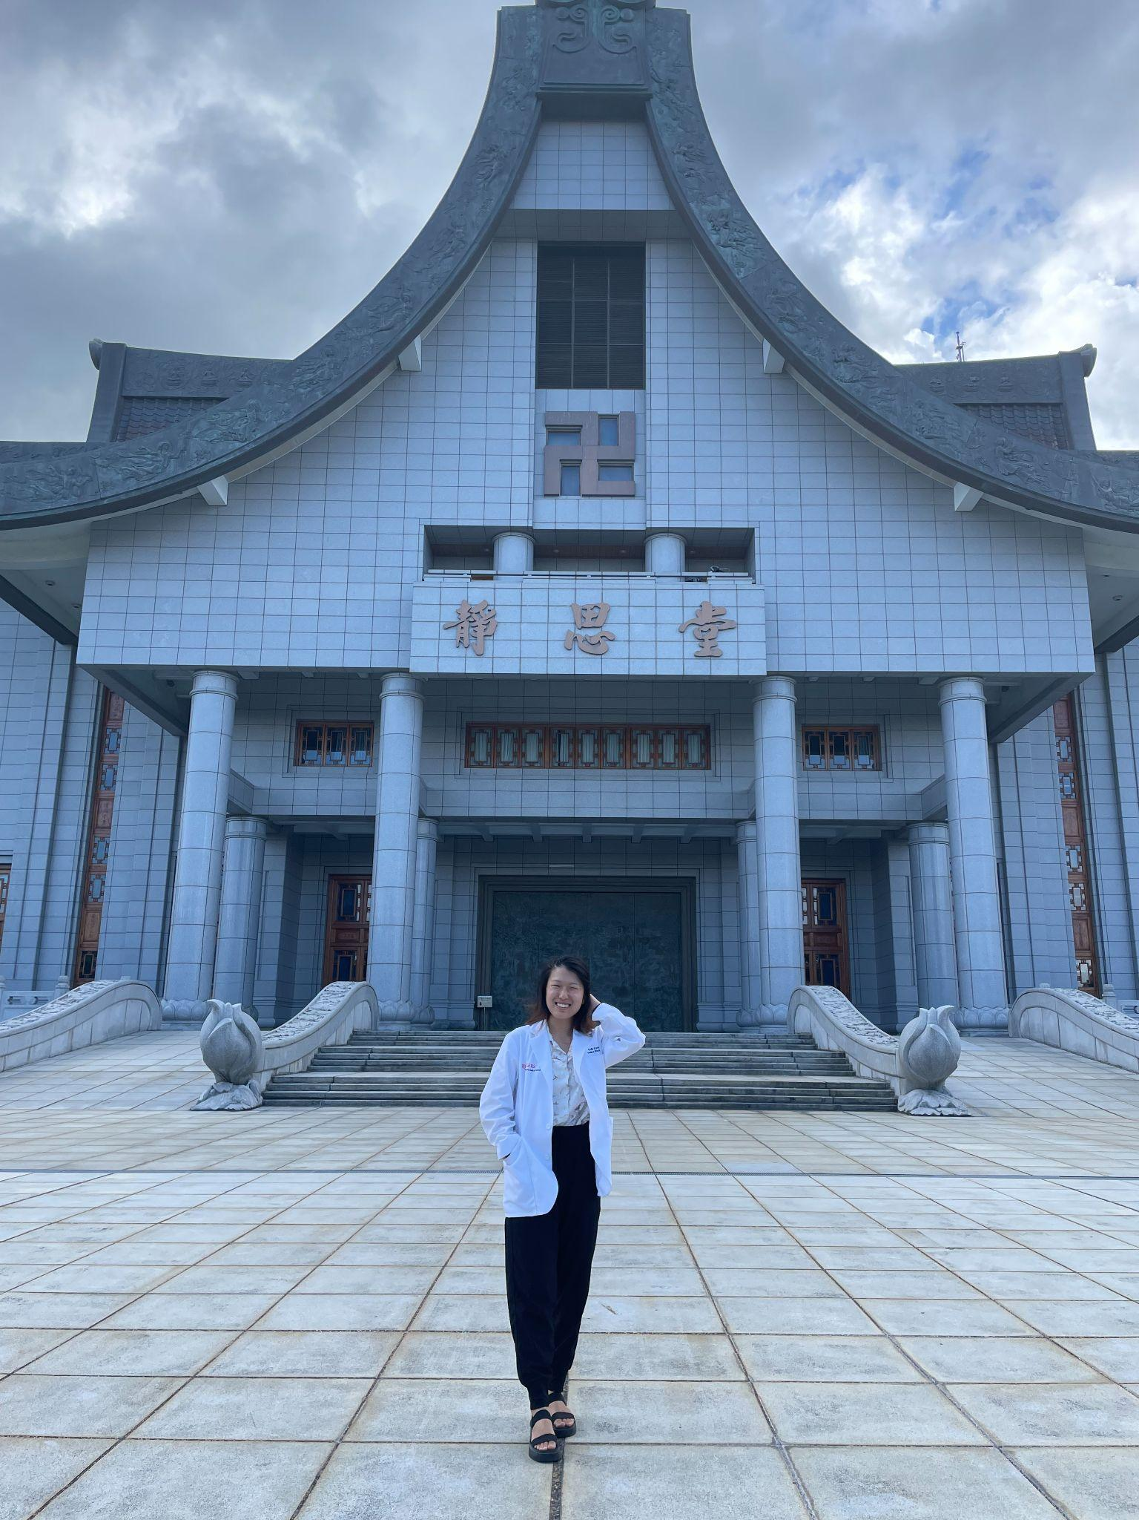

Why Taiwan

I chose to spend my summer in Taiwan because I wanted to see the country again, improve my language skills in Mandarin Chinese, and gain insight into how healthcare is practiced in Eastern countries. Before entering medical school, I taught English in Taiwan through the Fulbright program for two grant years. I wanted to spend the summer between 1st and 2nd year visiting my students and friends and continuing to explore the country. While I was living in Taiwan, I was insured through the National Health Insurance program and got to experience the healthcare system as a patient. I saw both Western and Traditional Chinese Medicine practitioners and valued being exposed to different cultural practices and perspectives in medicine. At NJMS, we see patients from all across the world: they have different cultures, languages, and medical knowledge. I specifically chose to rotate in the traditional Chinese medicine department because I wanted to learn more about different medical practices.

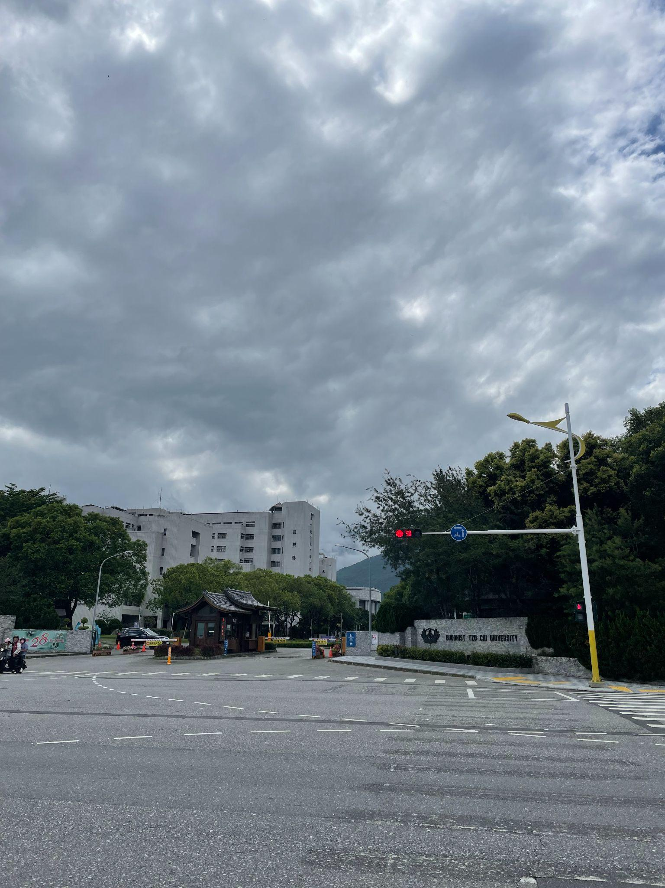
Entrance to Tzu Chi University Campus.

Rotation Experience – Overall Thoughts

The rotation was a self-directed experience. It’s as much or as little as you want it to be. If you want to see procedures or listen to patients' hearts with your stethoscope, you can ask the attending or resident. When I was assigned to residents, they asked me what I wanted out of the experience so they could help coordinate my schedule and reach out to doctors for me. It was very important to convey to the attendings and residents what I knew and did not know. When they were aware I was still in my pre-clinicals, they could adjust what they taught or asked me according to my knowledge base.

At their institution, rotations are typically two weeks long. Because of the connection with Rutgers, they allowed me to do one week in Chest Medicine and one week in Family Medicine/Palliative Care. I also did a two-week rotation in Traditional Chinese Medicine. The Tzu Chi Office of Education gave me a schedule for each week and informed me who I would report to via email. My schedule varied from seeing patients in clinic with attendings to going on rounds with residents in the in-patient wards. There are also department meetings and grand rounds that can be in your schedule.

Regarding language, I would recommend people know Chinese to gain a full experience. While I could speak conversational Chinese, I wasn’t familiar with medical terms. In addition, many patients in Hualien speak Taiwanese, a dialect of Mandarin, so I had to ask the residents and attendings to help translate. Most of the medical staff can speak English. For medical school, Taiwanese students learn the systems in both Chinese and English, so I was able to converse in English when I did not understand things in Chinese.

Through random moments in grand rounds or in the hallways, I got to meet other international students (one from LA and one from Spain) who came to do their training in Taiwan and grabbed meals with them. I would recommend taking initiative to meet the team and introducing yourself to the staff. I found that if I didn’t reach out to people, then they didn’t know how to help me. In addition to the social connections I made, I appreciated the time I had to myself to reflect on my summer and my first year of medical school.

Rotation Experience – Chest Medicine and Family Medicine

During my chest medicine rotation, I mostly shadowed one of the residents. When I wanted to see endoscopic procedures or was unsure of what to do for an afternoon, he helped me coordinate with other residents so I could experience rounding and taking patient’s histories. He also directed me to different attendings to work with throughout the week.

Because the medical students were on break, I attended lectures on different topics on chest medicine by myself. As a result, I got to know some attendings better and had more opportunities to ask questions. It was fortunate that I had just completed the pulmonary organ block, which provided good context for this rotation; I saw more clearly the application of the materials we learned. Overall, the rotation highlighted gaps in my pre-clinical knowledge and grounded the pre-clinical skills I learned into reality.

Shadowing at Tzu Chi, I also was able to learn more about Taiwan’s healthcare system. Unlike the US, Taiwan has single-payer healthcare, which is a universal healthcare in which the costs of essential healthcare are covered by a single public system. When I worked in Taiwan, my employer covered my health insurance. When I went to the doctors or emergency room, my medical bill rarely exceeded 500 NTD (approximately $20 USD). Compared to what I pay for healthcare in the states (often hundreds of dollars for a single visit), I found Taiwanese healthcare extremely affordable and accessible. However, when I visited the weekly mobile healthcare clinics in aboriginal villages outside of Hualien city, I learned the aboriginal populations there could not afford healthcare because of various socioeconomic factors. Since these populations have limited access to hospital services, the government subsidizes healthcare costs and builds local clinics for non-emergency services. During my Western medicine rotation, I was able to go with nurses for home visits and also visit the mobile healthcare sites. At these sites, Family Medicine doctors would visit villages weekly and check their blood pressure, medications, and, if needed, refer them to the hospital for X-rays and bloodwork.

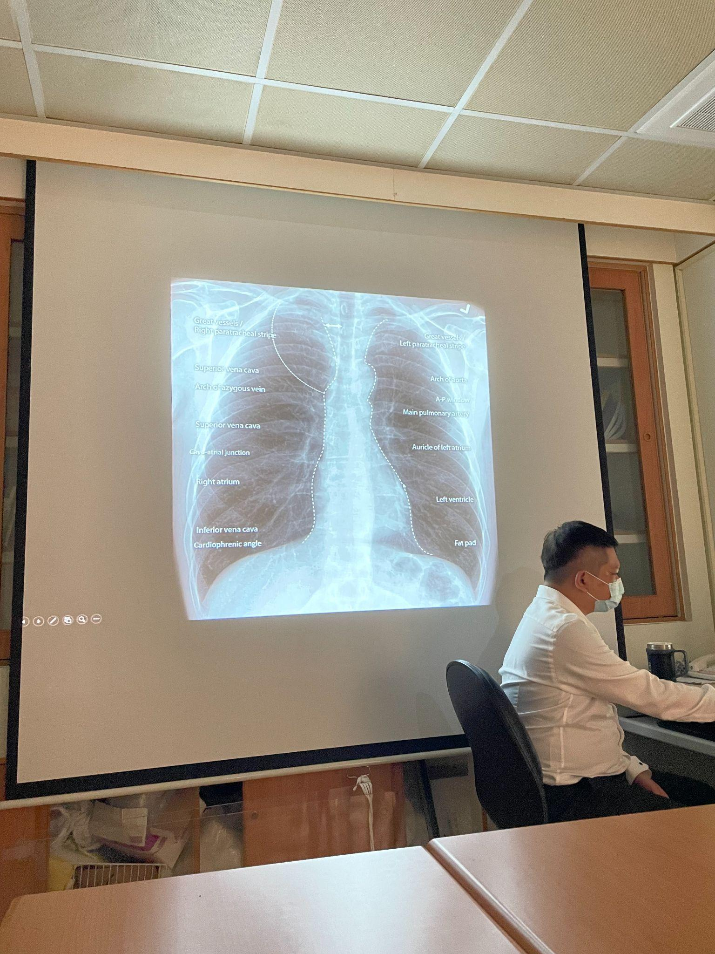
Lecture on reading chest X-rays.

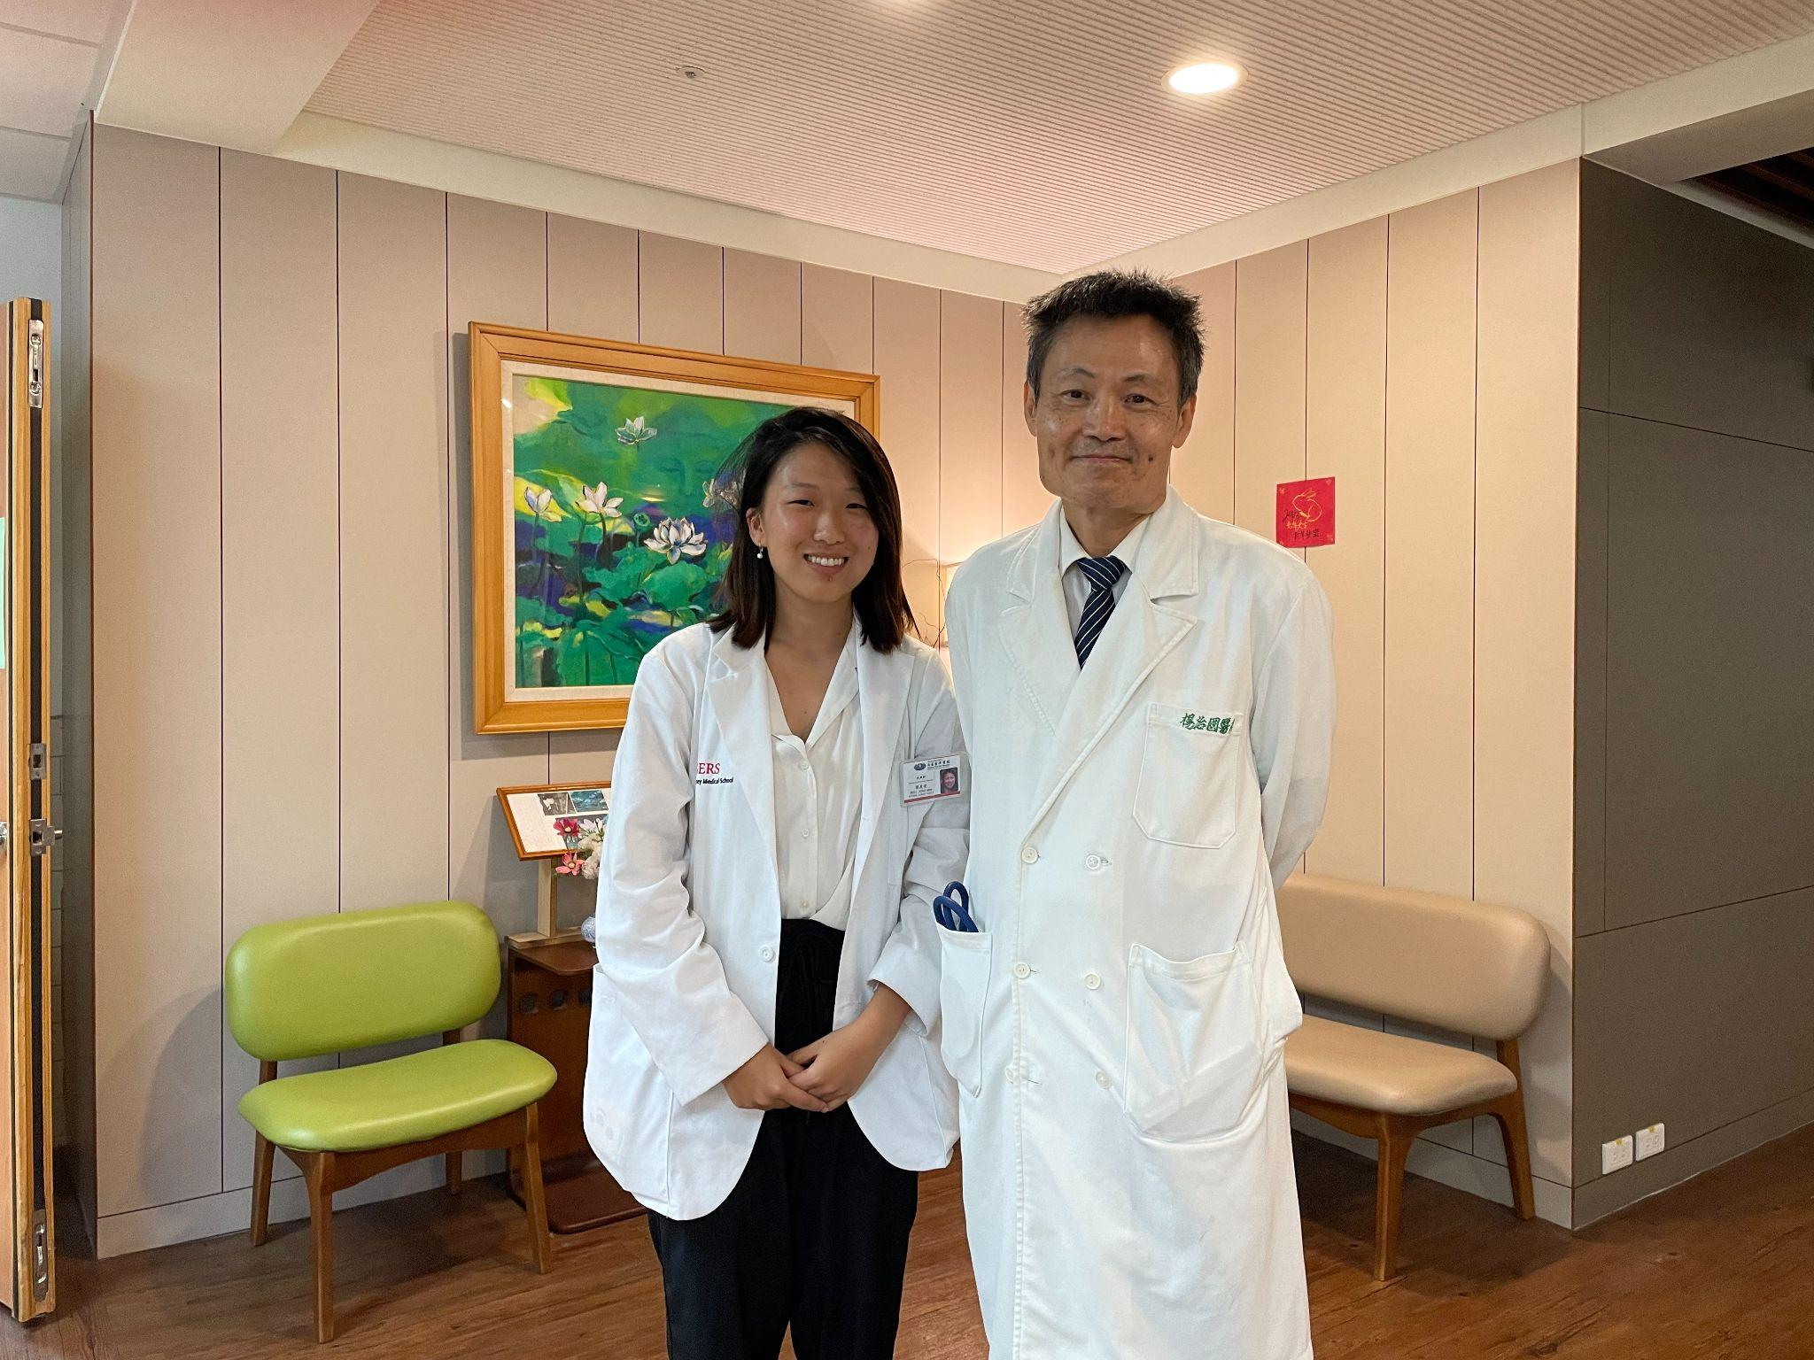
Shadowing with Dr. Yang.

Rotation Experience – Traditional Chinese Medicine (TCM)

I wanted to rotate in the TCM department to gain more exposure to the field. My first time seeing a practitioner was in Taiwan where a doctor read my pulse and asked about my illness history. The doctor’s diagnostic approach was different from what I was used to, but as my visit continued, I noticed that he was trying to pinpoint the root of my ailment as opposed to only alleviating my symptoms. I valued the holistic, future-oriented, compassionate approach he employed. This encounter along with my experience living in Taiwan inspired me to shadow TCM.

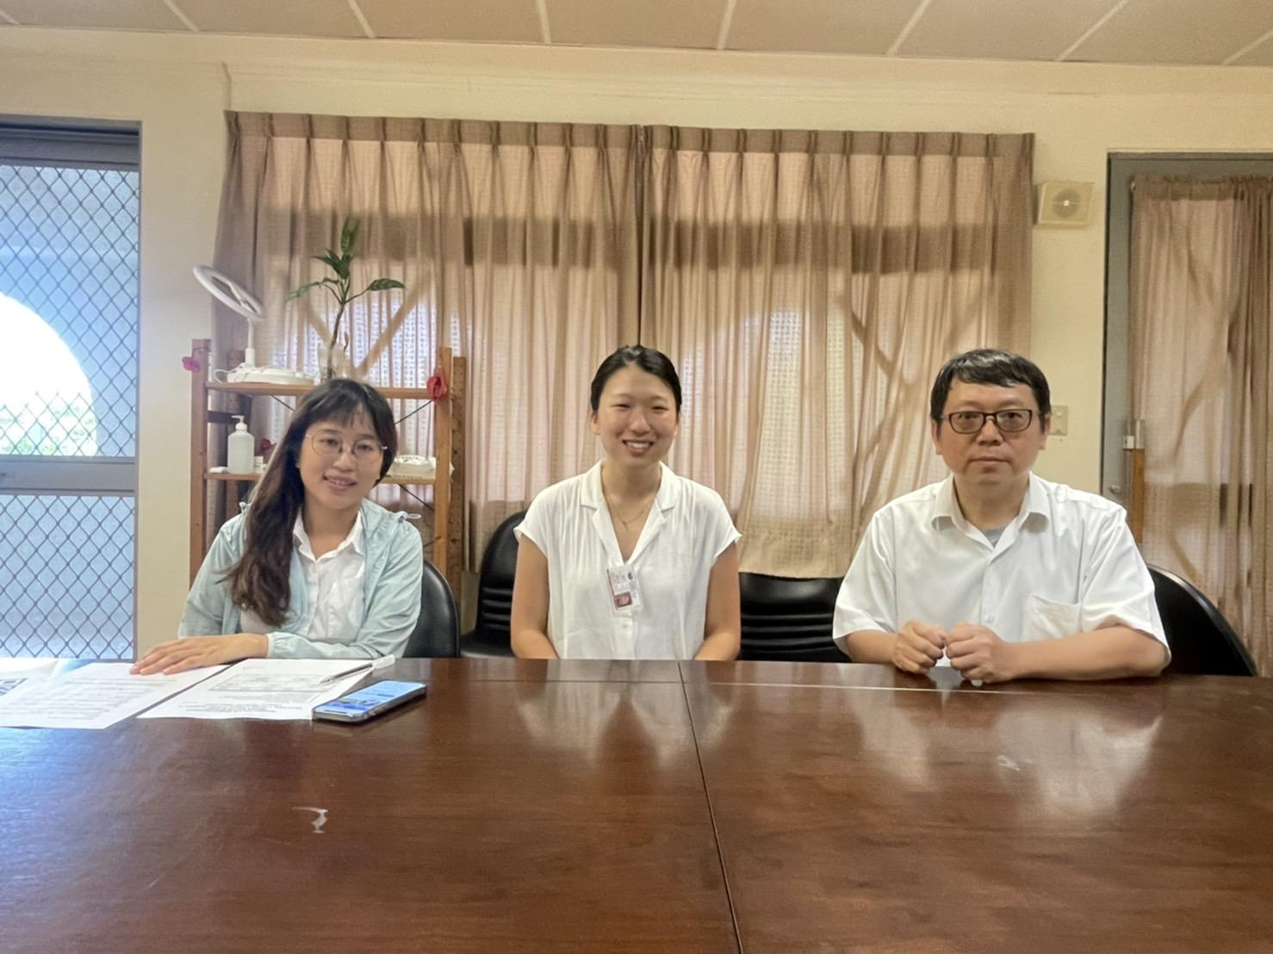
First day at the TCM department.

Similar to how my Western rotations were set up, there were morning lectures that covered different topics on TCM, opportunities to shadow doctors and residents in the clinic, and opportunities to go on home visitations with the residents. Patients who are unable to access transportation or physically incapable of going to the hospital can apply to receive home visitations where the doctors and residents go house to house to perform acupuncture and physical therapy.

One of the difficulties I faced during my rotation was the language barrier. While I was able to communicate with my hospital colleagues, I was unfamiliar with the Chinese terms for concepts like meridian lines, acupuncture points, and pulse reading. As I kept hearing the terms repeatedly and studied them in my own time, I had an easier time understanding what was going on in the appointments.

I learned that TCM encompasses not only acupuncture and prescribing medicine, but also elements of chiropractic, physical therapy, and cupping. I found it very interesting that two patients with completely different symptoms could be prescribed the same medicine and treatment because the origin of their illness is similar. On the other hand, one of the attendings mentioned that a patient concerned with a cough could go to different doctors and receive different prescriptions.

Attending the clinic reminded me of family medicine appointments I have observed in the US. The TCM doctors asked how patients have been recently and what has changed, but instead of using stethoscopes to listen to the heart and lungs, the doctors look at patients’ tongues and read their pulses to assess their condition. While patients are waiting for treatment, they continue to talk about their symptoms or events going on in their lives. Like Family Medicine, you need to be a good communicator, have good rapport, and want to have long-term relationships with patients. In addition, people come for all different medical reasons: palliative care for cancer and chronic illness, colds, fatigue, and muscle pains. Patients I met ranged from only seeing TCM practitioners to seeing a combo of both TCM and Western medicine doctors.

One of the highlights of my rotation was being able to shadow with other Tzu Chi University medical students when some first years came back from break. Because they were also in their pre-clinical years, it was easier for me to relate with them. Since I was unfamiliar with TCM, I did not know what questions I should ask, but hearing the residents answer and advise their juniors, I was able to learn more about the training and TCM school process. Most of the residents/students I worked with had previous careers or different majors before they decided to switch to TCM. Many chose to go into medicine because they themselves experienced TCM treatment or were inspired after seeing a family member fall ill. For example, one resident had a childhood illness and went to see Western doctors, but they were unable to treat her. After seeing an Eastern practitioner who helped heal her condition, she was inspired to study TCM.

A misconception I had about medicine abroad was that it would be completely different from my own experiences. Although TCM is a different philosophy of treatment from Western medicine, we medical students still study many years in school, learn to work with all kinds of people in the hospital (nurses, residents, students, technicians, attendings), and most importantly, at the core, we both want to treat people and help them feel better.

Coming out of this rotation, I am motivated to learn more about not only TCM but also other medical practices because in the future I may encounter patients who adhere to other forms of medicine. I want to be respectful of their beliefs and understand how to care for them.

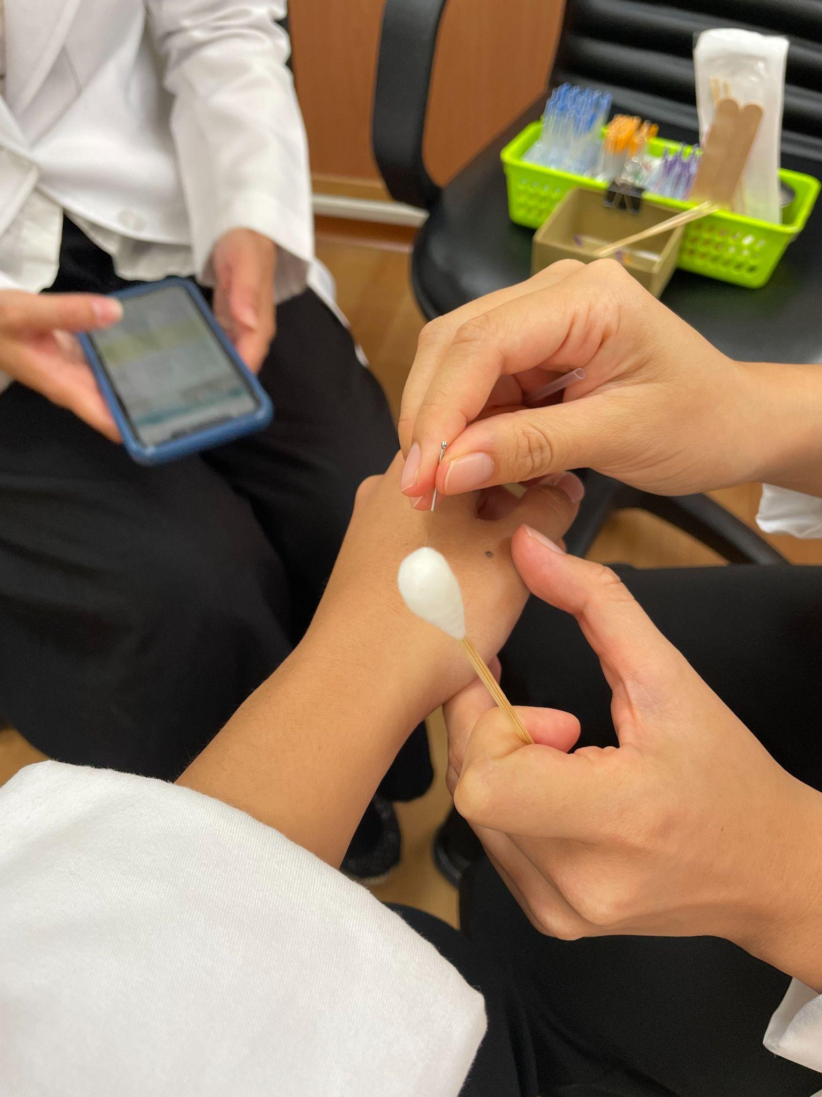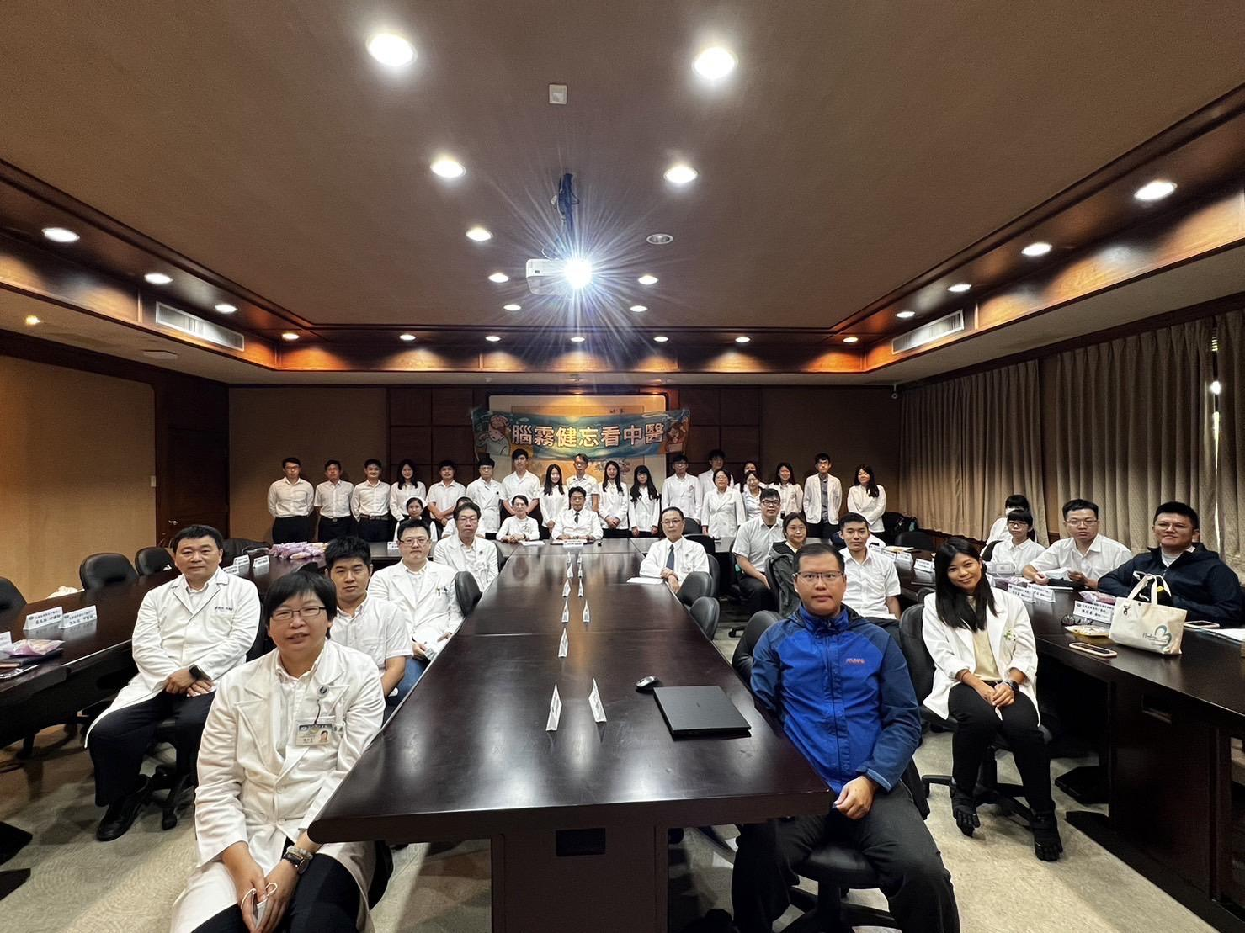
Receiving acupuncture on my hand (left). TCM department meeting (right).

Rotation Experience — Concluding Thoughts

I valued that this summer experience combined my interests: medicine, Chinese language, and traveling. Rotating at Tzu Chi Hospital was a unique opportunity to experience a healthcare system in a different country that I imagine will be hard to replicate unless I do an international rotation my 4th year. I am grateful for the medical students, residents, and attendings that welcomed me to their departments and taught me in the wards, home visitations, and classes.

Living in Hualien

In this final section, I’ll talk about what you can expect for housing, food, and transportation in Hualien.

While rotating at Tzu Chi, I lived in the campus student dorms. There are options to live off campus; however, I thought living on campus would be the most affordable and convenient option as it was about a 10-minute walk from the hospital. The student dorms were split by gender—male and female dorms. Usually these dorms have four students per room, but I did not have any roommates as most students went home for summer break. Nearby, there is the university gym that you could pay a daily fee for; I ended up running on the outdoor track in the evenings.

The university cafeteria is available for all three meals and costs anywhere from 10-40 NTD ($0.30-1.50 USD) per meal. In the hospital, there was also a cafeteria and 2 convenience stores where you could buy prepped meals and snacks with an employee discount. Because TzuChi hospital is a Buddhist organization, all food on their campus is vegetarian. I chose to eat off campus because I wanted to explore the different restaurants and food options. Within a 20-30 min walk, there are coffee shops and Thai/Vietnamese/Taiwanese/western/more restaurants available.

Summer in Taiwan can be brutal. It is extremely humid, with lots of mosquitoes, and the sun is very strong. Walking outside of the campus could become exhausting. My saving grace was finding a friend who lent me a bike for my stay. There are local bike shops that you could rent bikes out for hours/days, and you could also buy a secondhand bike on Facebook groups for pretty cheap. The bike gave me freedom to explore campus, get to the track easier, and go out to restaurants for food. I recommend wearing a helmet; many people in Taiwan do not wear helmets, but there are a lot of motorcycles and mopeds that crowd the streets, so riding a bike can be dangerous without a helmet.

After your weekday hospital shifts and on the weekends, you are free to explore Hualien. When I got out early from my clinic shifts, I rode my bike to the beach and along the Eastern Coast. In the evenings, you can visit the Dongdamen night market where you can eat Taiwanese and Aboriginal food and play games. Sometimes there are also dance and singing performances in the evenings. Taroko National Park is a beautiful place with hikes and natural gorges that you can get to with the local buses. The train station is also a 20-25 min walk that you can take to go to Taipei city or Taitung. I absolutely recommend that you explore Taiwan on the weekends; it is a beautiful country.

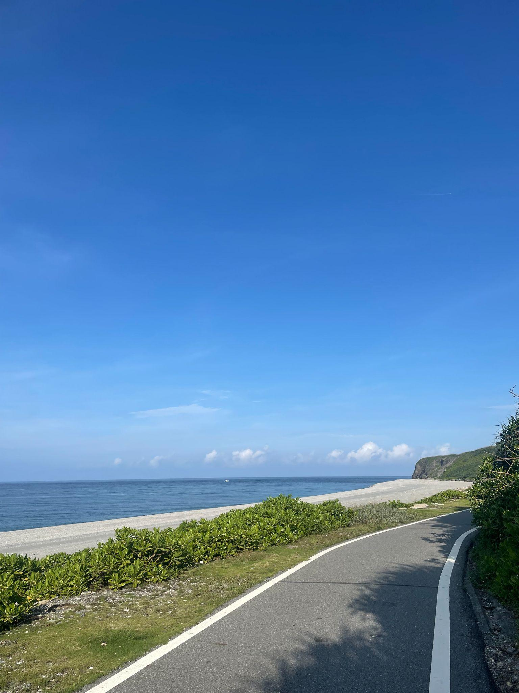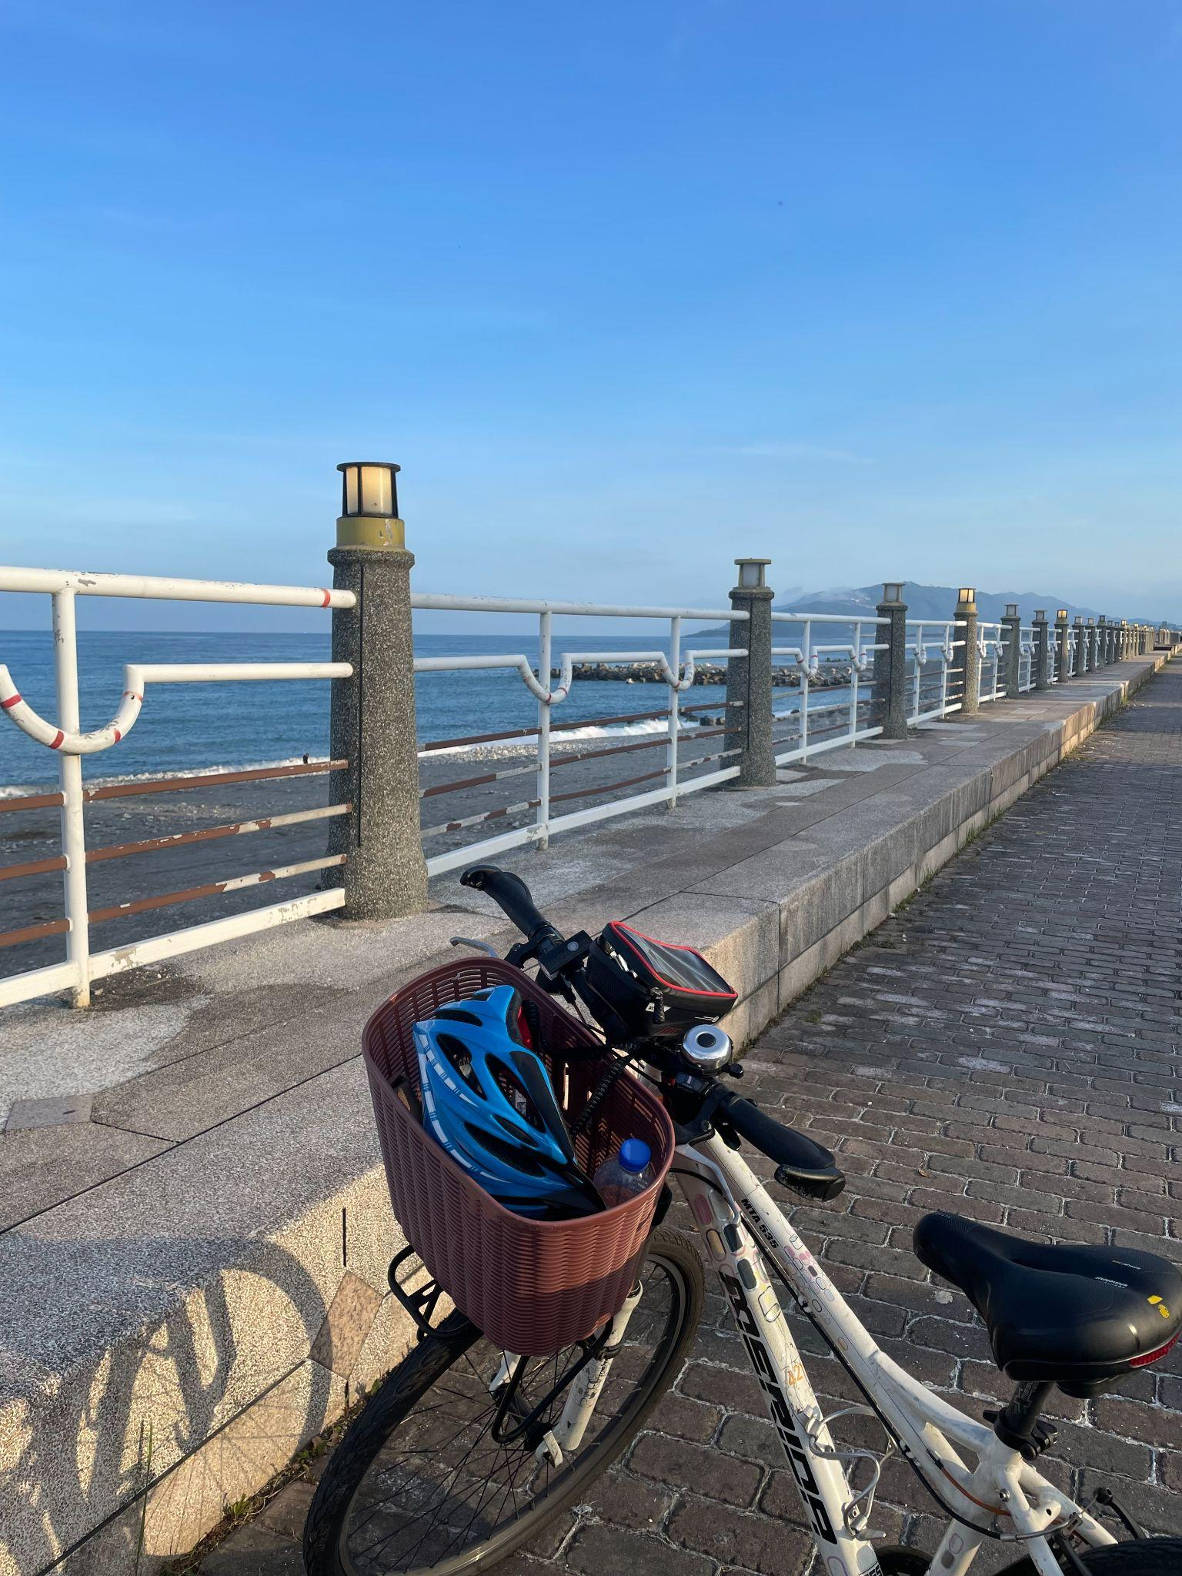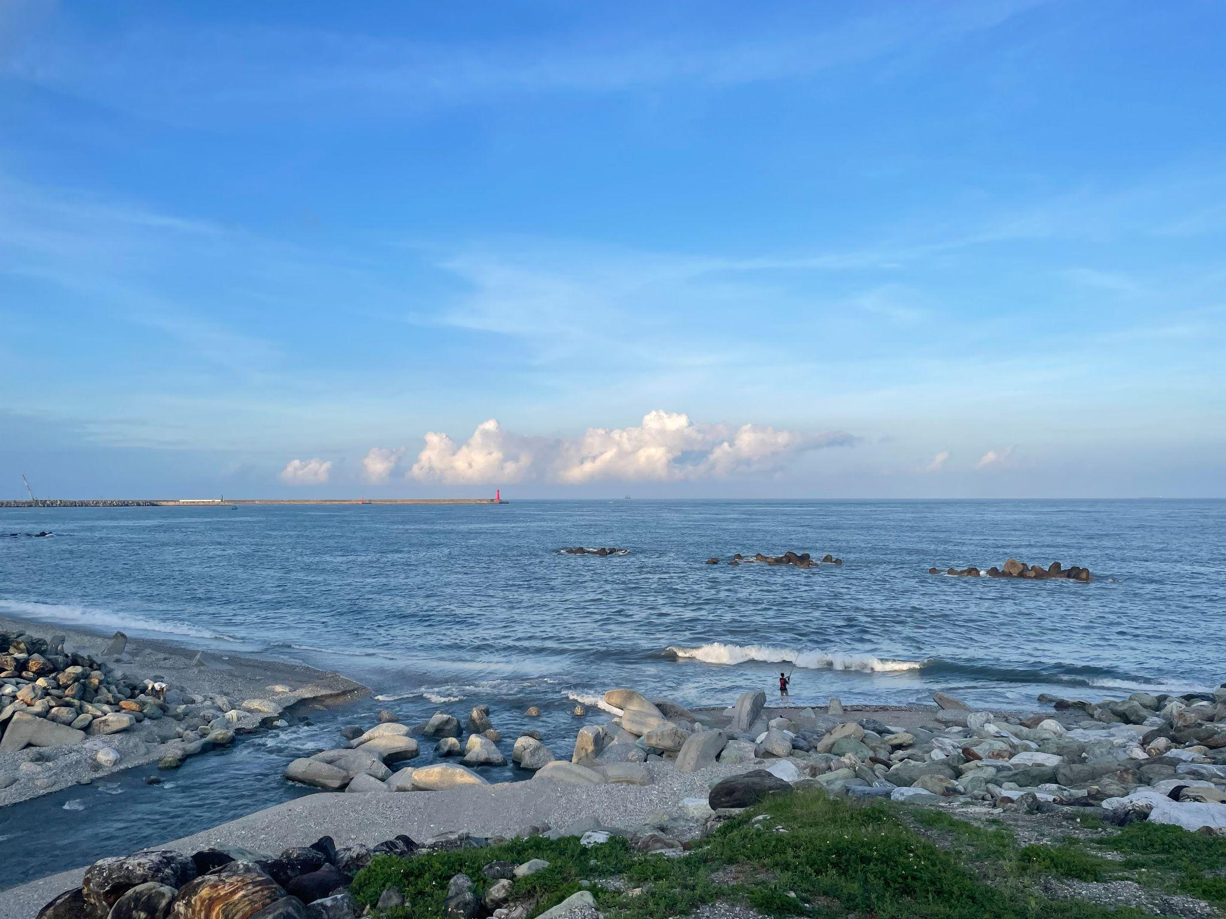
Bike ride along the Hualien Beaches.
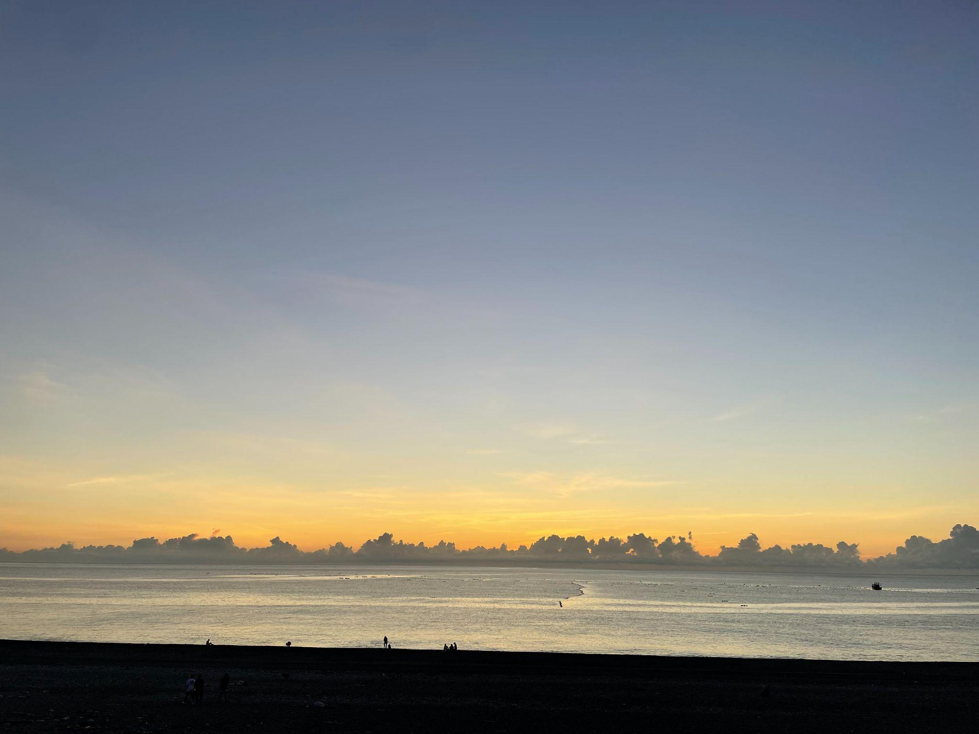
Sunrise at Qixingtan Beach.

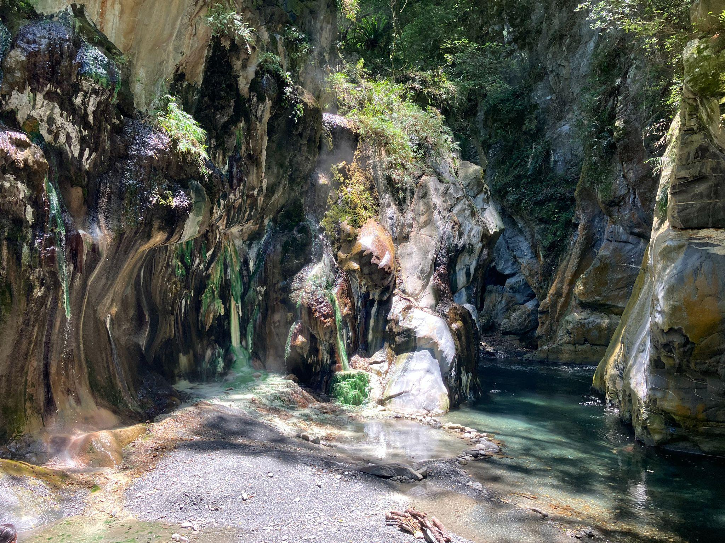
Hike to Lisong Hot Springs.

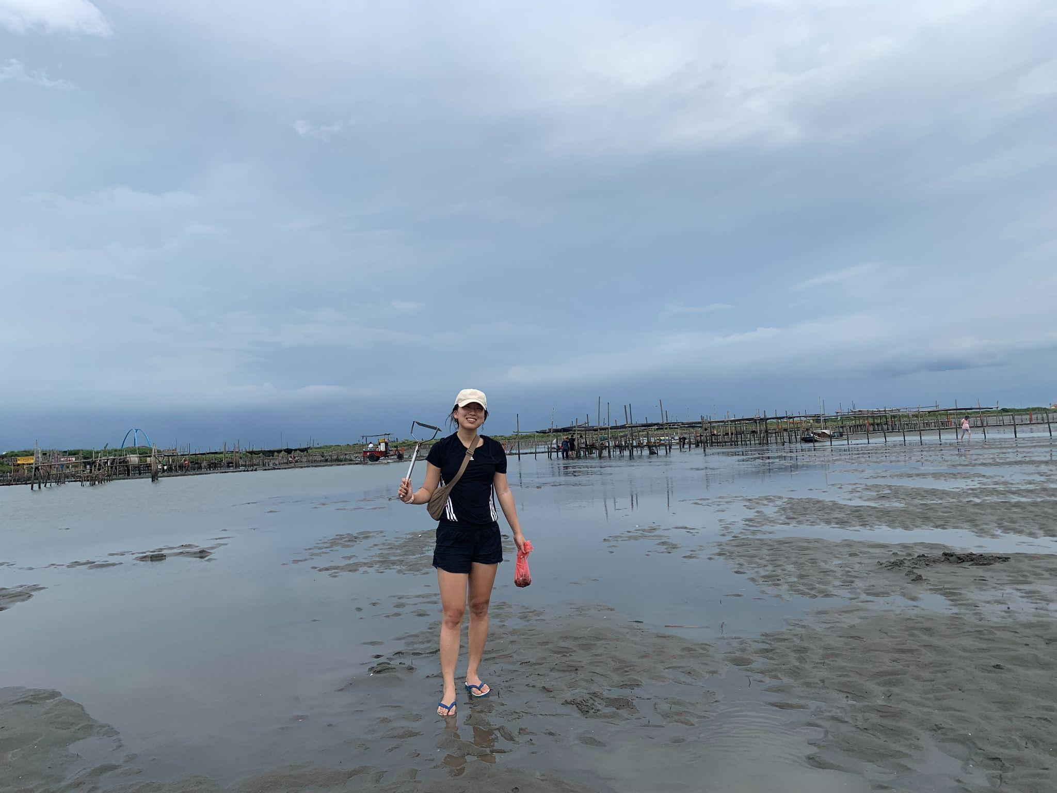
Going to a farm to pick clams.

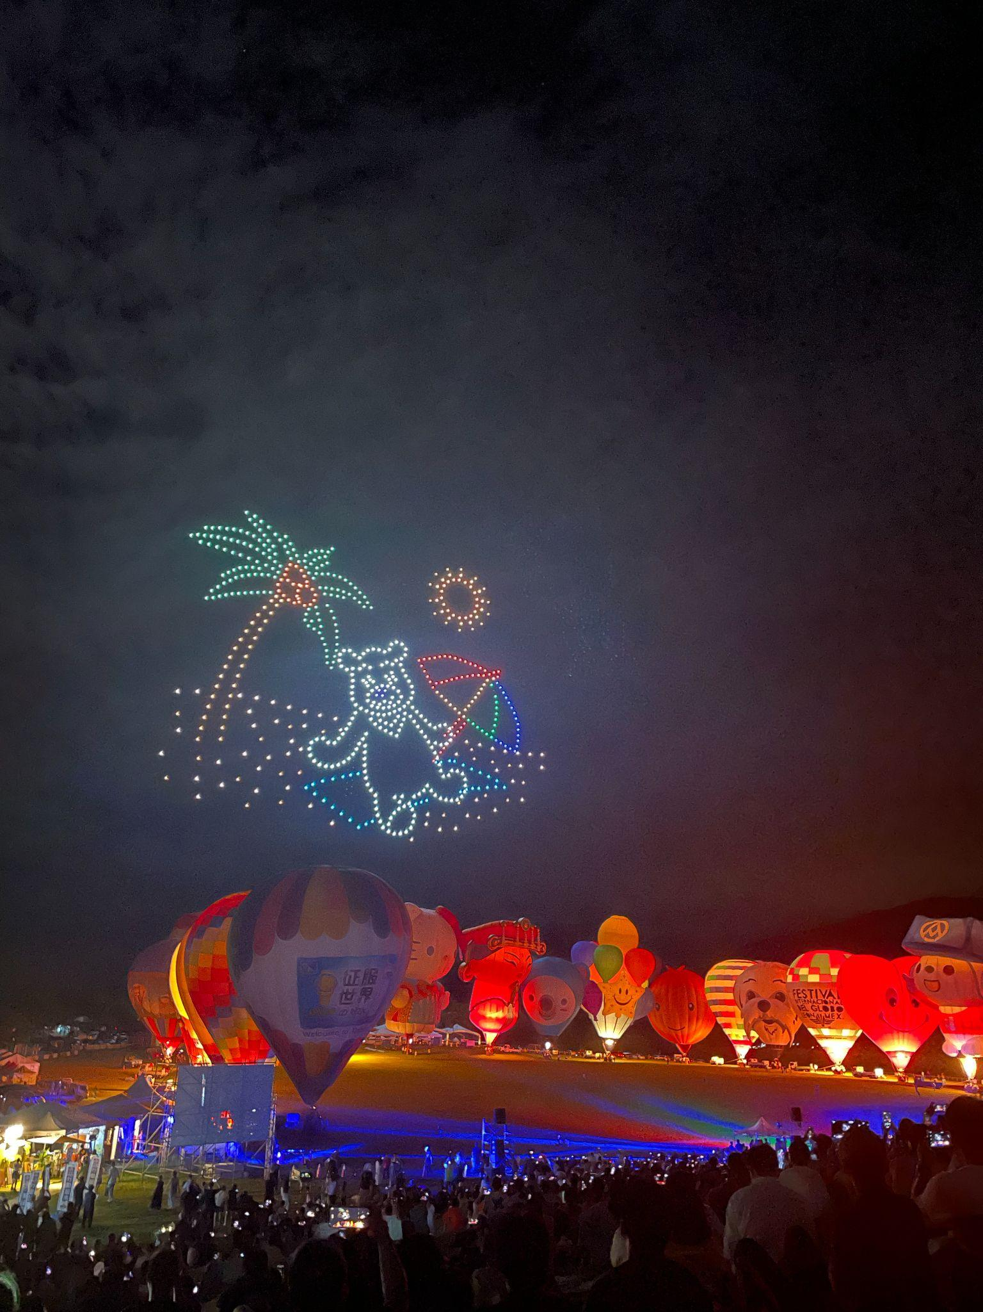
Taitung International Air Balloon Festival.

